

Agentic AI & Sports Intelligence
Towards Scalable and Autonomous AI Systems for Sports Decision-Making
Diogo Domingues Godinho

Master Thesis
presented as partial requirement for obtaining a Master’s Degree in Information Management

NOVA Information Management School
Instituto Superior de Estatística e Gestão de Informação
Universidade Nova de Lisboa

NOVA Information Management School
Instituto Superior de Estatística e Gestão de Informação
Universidade Nova de Lisboa

Agentic AI & Sports Intelligence
Towards Scalable and Autonomous AI Systems for Sports Decision-Making
by
Diogo Domingues Godinho

Master Thesis presented as partial requirement for obtaining the Master’s degree in Information Management, with a specialization in Business Intelligence.

Supervised by
Vítor Duarte dos Santos, PhD, NOVA Information Management School

December, 2025
Statement of Integrity
I hereby declare having conducted this academic work with integrity. I confirm that I have not used plagiarism, any form of undue use of information or falsification of results along the process leading to its elaboration. I further declare that I have fully acknowledged the Rules of Conduct and Code of Honor from the NOVA Information Management School.
[Lisbon, December 02, 2025]
Diogo Domingues Godinho
Acknowledgements
I would like to begin by expressing my sincere gratitude to Professor Vítor for his guidance, availability, and continuous support. His dedication was crucial to the development of this master’s thesis. I am deeply appreciative of the way he consistently pushed me to improve, kept me on track through regular meetings, and helped me meet my desired deadlines. I wish him all the best, both professionally and personally.
A special thanks to my family, friends, and closest loved ones, whose support, often without even realizing it, played a significant role in helping me complete this work. Their patience, presence, and understanding through the most challenging and demanding moments made all the difference, and I am truly grateful for each of them. And after the many “no’s” required to balance this master’s program with work, football, and other responsibilities… thank you for your understanding.
I am also thankful for the people who were part of this journey, even if only for a “chapter”. Your presence helped me more than you might imagine.
I want to thank my colleagues at work, from whom I have learned so much. Being able to apply what they taught me, draw inspiration from their experience, and rely on their patience during the more demanding periods of exams and deadlines has been truly valuable.
To my teammates and coaches, thank you for your understanding, encouragement, and availability. Your motivation reminded me of the purpose behind this journey and continuously pushed me to grow, both personally and academically.
Finally, I would like to thank NOVA IMS for providing an enriching learning environment throughout this master’s program. These past two years have been filled with knowledge, growth, and meaningful experiences that I will carry with me into the future.

Thank you for shaping not only this thesis but the person I have become

Abstract
This work presents an innovative approach to injury likeliness, performance projection, and athlete evaluation in sports (particularly within the context of the NFL) by integrating agentic artificial intelligence, generative artificial intelligence, and blockchain technology. The objective is to develop a system capable of processing both historical and real-time data to deliver accurate, accessible, and scalable insights, supporting teams with limited resources while enhancing results for those with greater analytical capacity. The methodology integrates three primary datasets: historical yearly player statistics, weekly performance data from previous seasons, and daily biometric metrics from a former player, including heart rate, sleep patterns, and fatigue levels. The proposed system employs Agentic AI to automate and coordinate multiple workflows encompassing data collection, analysis, and cross-referencing, while Generative AI transforms the resulting outputs into natural-language reports tailored for coaches, analysts, and medical teams. Blockchain technology ensures the integrity, traceability, and transparency of athlete records, enabling the creation of an “Athlete Passport” that consolidates player attributes, performance history, and health information. Designed for continuous operation, the framework stores data for longitudinal analysis and computes performance indices that support training-load management, injury prevention, and overall performance optimization. By providing an automated, user-friendly workflow capable of generating alerts and objective comparisons, this research demonstrates how the integration of these technologies can improve the efficiency and accessibility of sports analytics processes in both professional and semi-professional environments, paving the way for broader adoption of predictive analytics in daily team operations.

Keywords
Agentic AI; Artificial Intelligence; Sports Analytics; Sports Management; Data Analysis; Injury Forecasting

Sustainable Development Goals (SDG):


Table of Contents
1 Introduction 10
2 Literature review 13
2.1 Sports Management and Technology in Sports 13
2.1.1 Technology as an Enabler 13
2.1.2 From Big Data to Analytics Integration 14
2.1.3 Emerging Limitations and Structural Gaps 14
2.2 Injury, Data, and Forecasting in Sports 15
2.2.1 Injury Monitoring and Data Gaps 16
2.2.2 Modelling & Injury Forecasting: Breakthroughs & Challenges 16
2.3 AI, ML & Blockchain Applications in Sports 17
2.3.1 Machine Learning: scouting, predictions, and analysis 17
2.3.2 Agentic AI: automation and tool integration 19
2.3.3 Generative AI: narrative, reporting, and communication 19
2.3.4 Blockchain: securing athlete data, transparency, and ownership 20
2.3.5 Synthesis and implications 20
2.4 Challenges & Opportunities 21
2.5 Agentic AI & Sports Management – A systematic Literature Review 22
2.5.1 PRISMA Protocol 22
2.5.2 PRISMA Execution 22
2.5.3 PRISMA Results Analysis 29
3 Methodology 35
3.1 Overview 35
3.2 Exploration Phase 36
3.3 Conceptual Phase 36
3.4 Experimental Phase 36
3.5 Conclusive Phase 37
4 Experimental Design – Agentic ai framework 38
4.1 Datasets 38
4.2 Agentic AI Framework 39
4.2.1 Workflow 1 – Weekly Report 42
4.2.2 Workflow 2 – Injury Alerts 44
4.2.3 Workflow 3 – Performance Assessment & Projection 48
4.2.4 Team Management Platform 50
4.3 Athlete Passport 50
4.4 Testing & Expected Outputs 52
5 Results and Discussion 55
6 Conclusions and Future Research 60
Bibliographical References 62
Appendix A – Datasets 67
Appendix B – Team Management Platform 70
Appendix C 75

List of Figures

Figure 2.1 – PRISMA Execution 26
Figure 3.1 - Phases of the Methodology 35
Figure 4.1 – Agentic AI Master Workflow 41
Figure 4.2 – Framework Key Foundations 41
Figure 4.3 – “Workflow 1 – Weekly Report” Key Modules 44
Figure 4.4 – Model Performance & Results 46
Figure 4.5 – “Workflow 2 – Injury Alerts” Key Modules 48
Figure 4.6 – “Workflow 3 – Performance Assessment” Key Modules 50
Figure 4.7 – “Athlete Passport” – Blockchain Approach 51
Figure 5.1 – “Workflow 1 – Weekly Report” Output 55
Figure 5.2 – “Workflow 2 – Injury Alerts” Output 56
Figure 5.3 – “Workflow 3 – Performance Assessment” Output 57

List of Tables
Table 2.1 - Systematic Review´s Research Questions 23
Table 2.2 - Systematic Review’s Keywords 24
Table 2.3 – Systematic Review’s Resource Databases 24
Table 2.4 – Systematic Review’s inclusion and exclusion criteria 25
Table 2.5 – Systematic Review’s studies included 29

List of Abbreviations and Acronyms
ACLR Anterior Cruciate Ligament Reconstruction
ACWR Acute:Chronic Workload Ratio
ADASYN Adaptive Synthetic Sampling
AI Artificial Intelligence
AUC Area Under the Curve
BMI Body Mass Index
CNN Convolutional Neural Network
DNP Did Not Play
F1 Model evaluation metric balancing precision and recall.
GPS Global Positioning System
IIS Injury and Illness Surveillance
ISMS Intelligent Sports Management System
KPI Key Performance Indicator
LLM Large Language Model
LSTM Long Short-Term Memory
MAGI Managerial Artificial General Intelligence
ML Machine Learning
ML-PA-IP Machine Learning for Performance Analysis and Injury Prediction
MVP Most Valuable Player
NFL National Football League
NGS Next Gen Stats
NFT Non-Fungible Token
PPR Points Per Reception
PoC Proof of Concept
PRISMA Preferred Reporting Items for Systematic Reviews and Meta-Analyses
RF Random Forest
RFID Radio Frequency Identification
SVM Support Vector Machine
UI User Interface
UWB Ultra-Wideband
VAR Video Assistant Referee
XAI Explainable Artificial Intelligence
XGBoost Extreme Gradient Boosting

Introduction
In sports, preventing injuries is as critical as optimizing performance. This thesis explores how artificial intelligence, particularly Agentic AI, can have a positive impact in this environment by making health and performance data more accessible, streamlining decisions, and lowering monitoring costs.

Predicting injury risk in sports is a well-established goal in modern sports medicine, as it is critical for minimizing physical setbacks optimizing athletic performance, and improving recovery strategies (Edouard et al., 2024). By accurately anticipating injury risks, teams can design individualized training and rehabilitation programs that help athletes avoid injury and recover more efficiently when injuries do occur (Vincent et al., 2022). This shift from reactive treatment to proactive prevention, marks a significant advancement in sports health management (Fagher et al., 2019).

Building on this injury-centered analysis, the study also incorporates performance forecasting and market valuation by leveraging historical player data from previous seasons. This information will be used to define an overall performance index (explained in a subsequent chapter), which enables more precise comparisons across prior player seasons and supports the identification of historical trends through performance data.

This framework has potential applicability across both elite and lower levels of competition, as well as in a variety of sports contexts. At lower competition levels, analytics resources are scarcer. Many teams operate without a dedicated analytics department or routine player monitoring processes. Yet, evidence shows that data analytics can enhance performance and support more informed decision-making (Davis et al., 2024; Andersen, 2024). This underlines the importance of developing AI-driven frameworks that remain scalable, practical, and accessible across all tiers of sport.

However, traditional prediction methods face persistent challenges, including variability between athletes, biological differences, and the complexity of modeling multiple interacting risk factors (Mausehund & Krosshaug, 2024). Data-related issues, such as inconsistencies in reporting, limitations in availability, and quality concerns, further complicate prediction accuracy (Nassis et al., 2022). The constantly changing nature of an athlete’s physiological state also compounds these difficulties, as conventional models often lack the ability to capture real-time dynamics (Rossi et al., 2018).

This dissertation focuses particularly on NFL Players like defensive backs (cornerbacks & safeties) for injury probability analysis, and later, skill position players (wide receivers & running backs) for performance forecasting. These athletes are regularly exposed to high-speed, change of directions, non-contact stresses, making them more susceptible to injuries such as ACL tears and hamstring strains. Despite this elevated risk, there are few accessible systems capable of translating week-to-week performance data into early-warning injury alerts or objective fatigue scores (Halson, 2014; Haller et al., 2022).

This dual focus gains further relevance when considering that in elite-level sports vast amounts of performance, workload, and injury history data are collected. However, much of this information remains underutilized in predictive decision-making processes (Lindsey, 2016), a gap that can be addressed using low-code and no-code AI agents & automations coupled with accessible user interfaces.

This paper presents a comprehensive analysis of the transformative role of artificial intelligence (AI) in assessing injury probabilities and preventing sports injuries, projecting player performance, and facilitating objective athlete evaluation by leveraging historical performance data as a comparative baseline. The project further explores the integration of Agentic AI for intelligent automation and tooling integration, Generative AI for narrative, tailored and insightful reporting, and blockchain for secure athlete record-keeping. The central aim is to understand how to harness these technologies to produce data-driven insights in controlled, practical conditions, focusing on improving the quality, consistency, and accessibility of sports analytics data across diverse contexts.

In essence, the objectives are, more precisely, to design and validate a methodology that leverages Agentic AI and Generative AI to automate weekly performance analyses, enable continuous injury monitoring through real-time alerts, and generate actionable insights into NFL players’ health status, performance potential, and future market valuation.

To achieve this overarching objective, the following intermediate objectives were established:
- Conduct a comprehensive literature review on Agentic AI and its applications within sports management;
- Examine the conceptual foundations of blockchain technology to evaluate its applicability for maintaining secure and transparent player data logs within an Athlete Management Platform;
- Collect relevant information and historical datasets to support predictive modeling and insight generation;
- Design a structured methodology for combining Agentic and Generative AI through automated workflows and tooling integration;
- Develop a centralized platform to integrate AI tools and present AI-generated reports;
- Implement a prototype demonstrating the functional workflow and report generation within the centralized platform;
- Create templates and tailored prompts for generating detailed, domain-specific reports and insights;
- Validate and assess the prototype results.

AI-driven approaches address these shortcomings by integrating diverse data sources, including wearable sensor outputs, biomechanical assessments, performance metrics, and psychological indicators, to construct individualized athlete profiles (Topol, 2018). Beyond enhancing prediction accuracy, AI systems can deliver real-time monitoring and feedback, continuously tracking athlete condition during training or competition, and alerting coaches or medical staff to potential risks before they escalate (Rossi et al., 2018). Moreover, AI enables longitudinal tracking of players’ progress and performance across seasons.

Thus, the approach outlined in the following chapters aims to address this gap by proposing a system that can be seamlessly integrated into a team’s existing workflow, even in resource-constrained environments, without disrupting daily schedules. The intended contribution is not to replace human expertise but to complement it, embedding analysis and data-driven decisions into everyday operations to support training, player health, and game preparation.

The proposed framework uses AI to automate the detection of patterns and variations in health and performance data, track progress over time, and generate personalized training and recovery plans by referencing historical player data (almost as a “Knowledge Base”) for analysis. It then translates these findings into accessible, natural-language reports for coaches, analysts, and medical staff. Complementarily, Blockchain technology is expected to ensure data transparency, integrity, and traceability (Kashyap & Chowdhury, 2024), enabling the creation of a universal digital Athlete Passport that securely stores player attributes, statistics and records, historical performance, and medical records.

Furthermore, the use of official existing metrics like NFL PPR Fantasy Points as an external validation adds an objective benchmark that improves player and team performance evaluation to enhance the final output.

In summary, this dissertation, hopefully, will prove how integration of Agentic AI (workflow logic combined with tool integration), Generative AI (summarization and synthesis), and blockchain-based (secure logging and historical data ownership) athlete records can improve efficiency, autonomy, and accessibility of custom-made reports for injury analysis and likeliness, performance projection, and player evaluation in professional and semi-professional sports contributing to the state of the art with an Agentic AI approach, adding value for further scientific investigations on related topics.

Literature review
This literature review serves as a foundation for the thesis by synthesizing research at the intersection of technology, sports management, and artificial intelligence. It first considers key aspects of sports management, emphasizing injury prevention and the impact of emerging technologies in decision-making. It then addresses data-driven methodologies and intelligent systems, highlighting Agentic AI in tooling and automation and Generative AI in tailored and analytical reporting, accenting their potential applications in sport. It then addresses the conceptual foundations of blockchain technology as a method of secure and transparent athlete data management. The sections that follow synthesize established contributions and emerging directions, identifying key applications relevant to our artifact modelling while highlighting gaps that remain unresolved, with the aim of avoiding known errors in the scope of sports technology by following best practices identified, positioning the research within the trajectory of AI innovation in sport.

Sports Management and Technology in Sports
Sport management is broadly defined as the field of business concerned with sports and recreation (Blanchette, 2022). The field encompasses activities such as planning, organizing, budgeting, controlling, directing, and evaluating various organizations within the sports domain. Over the years, its scope has expanded beyond the traditional administrative functions, now including sports marketing, analytics, sponsorship, and facility management (Belzer, 2014). Essentially, sports involve competition that has strategy and often requires teamwork to win. The level at which one practices sports can either be recreational, competitive, or professional, with a rare category of elite athletes who pursue sports as a full-time job (Pressler & Niebauer, 2020). This thesis focuses primarily on the professional level, where data is more accessible, but also considers implications for broader contexts where professional infrastructures may not exist, exploring its applicability and potential benefits for lower-level teams.

Technology as an Enabler
The growth of sport management has coincided with an increasing reliance on technology as a performance and organizational enabler. “Technology in sports” encompasses tools such as wearables, GPS tracking, video and performance analysis systems, athlete management software, and event and facility technologies. These tools help with workload and wellness monitoring, coaching and tactical assessments, fan engagement and strategy development, commercial relations, improving safety and even fairness through mechanisms such as officiating aids like VAR. Historically, decision-making was based on the observations of the coaches, time analyses, and manual logs. The past decade sports technology has improved with the introduction of data dashboards and semi-automated alerts, but despite these advances, access to technology remains uneven. Only a fraction of athletes and teams currently use sport-specific systems, as high costs, limited staffing, and vendor fragmentation continue to restrict broader adoption.

From Big Data to Analytics Integration
The rapid increase in data availability has opened new avenues for sports research and management. As George et al. (2014, 2016) argue, the growing wealth of information allows researchers to address both long-standing questions and entirely new areas of inquiry. This expansion means that, more than ever, new insights can be formulated and substantiated, with data serving as a foundation to support and validate emerging perspectives. In practice, “Big data and analytics have become an essential component of organizational operations… This is no different in sport management” (Watanabe et al., 2021). Analytics holds promises not only for performance optimization but also for influencing business and strategic choices. However, as Shields (2017) emphasizes, “The successful use of analytics in sports, both on the field and off, comes down to integrating analytics within an organization.” Therefore, in addition to technical tools, organizational alignment, a common language, and accessible systems are necessary for effective implementation.

Beyond organizational strategy, technology is being increasingly applied across multiple dimensions to both enhance performance and safeguard athlete health. Real-time biomechanical data from wearables and smart equipment helps professionals identify injury risks early and tailor rehabilitation protocols (Van Eetvelde et al., 2021). For example, in professional football, the NFL has developed the ”Digital Athlete”, a league-wide platform that incorporates artificial intelligence and machine learning to conduct real-time risk analysis and identify potential injuries as they occur, enabling immediate intervention (Langton, 2024), a concept that aligns certain dimensions of this project. This integration of monitoring and AI demonstrates the growing recognition that technology is not limited to organizational or commercial domains but can directly contribute to athlete well-being by simultaneously enhancing performance and protecting long-term health, leveraging data analytics to inform decisions and optimize outcomes.

Emerging Limitations and Structural Gaps
While new technologies bring clear opportunities, they must also be evaluated for feasibility, equity, and practical implementation. Even though advantages are evident, integration and resource availability may pose barriers in certain contexts, as has been the case with other technological innovations or industrial sectors. Besides, fragmentation still exists even as these innovations are developed: data is still separated across vendors, practices vary depending on the level of competition, and adoption outside of elite organizations is constrained by staffing and cost issues.
In addition, drawing from my own experience of having played throughout much of my life, and continuing to do so today, it is evident that such technologies remain largely inaccessible in lower-level leagues. This personal perspective has further motivated me to examine this challenge and explore potential solutions.

Injury, Data, and Forecasting in Sports
One of the biggest risks to an athlete's performance, longevity, and organizational success is still injuries. They can result in long-term physical and psychological consequences, lower performance levels, and jeopardize training availability (Bahr et al., 2020; Wang et al., 2024). These effects are especially noticeable in professional settings where the health of athletes affects team results and financial stakes. Thus, injury prevention becomes a key component of sports management strategy as well as a medical or physiological issue.
Contact and Non-Contact Sports
One must comprehend the nature of injuries to better understand their underlying causes. The level of physical contact in sports affects injury patterns. Severe traumatic injuries are more common in contact sports like football, rugby, and hockey because of the frequent collisions and tactical encounters (Hind et al., 2020). Although collision rates are generally lower in non-contact sports like volleyball, badminton, or gymnastics, athletes are still susceptible to injuries from biomechanical imbalances, overuse, and exhaustion (John, 2024; Prieto-González et al., 2021). Building on earlier discussion, NFL players will be used as the empirical reference point in this thesis, focusing primarily on non-contact injuries that happen within a contact-sport ecosystem.
Multifactorial Causes of Injury
Understanding sports injuries requires acknowledging their multifactorial and non-linear origins. According to Bittencourt et al. (2016), "the multifactorial complex nature of sports injuries arises from the complex interaction among a web of determinants, rather than the linear interaction between isolated and predictive factors". Several domains are covered by these determinants. Characteristic variables such as age, sex, body mass index, height, and weight influence susceptibility to specific injuries and affect recovery timelines (Zadeh et al., 2021). Physiological variables including heart rate, breathing rate, training load, and energy expenditure shape the body’s stress-response balance and highlight whether workloads are distributed effectively across tissues. Anxiety, stress, sleep patterns, and mental health are important psychological factors as well; it has been demonstrated that depressed mental states increase the risk of injury and postpone recovery (Clemente et al., 2021). The interaction among these domains explains why seemingly identical external conditions may produce divergent injury outcomes across individuals.

Injury Monitoring and Data Gaps
Given these complexities, injury surveillance has been positioned as a critical foundation for prevention and forecasting. Injury and illness surveillance (IIS) “initiates the sequence of injury and illness prevention,” yet current approaches remain “not harmonized or widely documented,” and mature programs are rarely implemented at non-elite levels (Sprouse et al., 2024). This situation is further compounded by structural barriers with coaches commonly citing time demands, financial constraints, and program complexity as limitations to adoption (Minnig et al., 2022). Community and amateur organizations encounter "substantial contextual difficulties…including limited staff and resources" (Ekegren et al., 2014), as previously mentioned. Even at the highest levels, uncertainties persist, with limited information available and little consistent focus on data quality (Ekegren et al., 2016).

Modelling & Injury Forecasting: Breakthroughs & Challenges
As documented across multiple studies, a consistent pattern emerges: the absence of standardized surveillance and universal procedures complicates the development of forecasting models. The potential for trustworthy predictive insights is limited by small sample sizes, inconsistent injury definitions, and heterogeneous measurement techniques, which also make studies less comparable (Leckey et al., 2024). Even at the elite level, “reporting recurrent or subsequent injuries remains inconsistent, and few studies have utilized subsequent injury models” (Bitchell et al., 2020). Beyond this, the fragmented nature of available data, often concentrated in elite settings while underreported in amateur and community sport, creates further imbalance (Ekegren et al., 2016, Sprouse et al., 2024). While injuries are inherently multifactorial and non-linear, making them challenging to model using traditional methods, quality problems like missing values, inconsistent reporting, and incomplete follow-up add extra noise (Bittencourt et al., 2016). Although machine learning can address complexity, its performance is constrained by limited datasets and the lack of interpretability, making it challenging to translate predictive insights into actionable strategies; nevertheless, research demonstrates notable advances in injury forecasting, offering new opportunities like “(to) improve prediction and allow proper approaches to injury prevention” (Van Eetvelde et al., 2021).]
In team sport contexts, “the application of artificial intelligence (AI) opens an interesting perspective for predicting injury risk and performance” (Claudino et al., 2019), particularly because these models can integrate heterogeneous and non-linear factors into actionable insights. The same rationale can be extended to other domains, such as forecasting future performance, thereby encompassing the entire ecosystem of a team or sport to generate forward-looking insights.
Taken together, once injuries and their underlying causes and consequences are considered, literature underscores that injuries in sport are complex, data collection remains inconsistent, and forecasting is constrained by infrastructural and methodological gaps. These challenges demand not only better data integration but also advanced computational approaches capable of handling real-world imperfections. As such, the field increasingly converges on the need for AI-driven, tool-integrated workflows, particularly in areas such as monitoring injury probabilities, that can automate surveillance, flag probable risks, and forecast performance trends to, hopefully, mitigate some of these constraints. This complexity ultimately “offers an opportunity to treat sporting injury as the complex phenomenon it appears to be, to consider the non-linear context surrounding athlete injuries, and to provide a supplement to practitioner reasoning, to facilitate quicker decisions” (Owen et al., 2024).

AI, ML & Blockchain Applications in Sports
Artificial intelligence (AI) now underpins a growing share of decision-making in sport, spanning on-field performance, player health, and front-office operations. Classical machine-learning (ML) approaches remain foundational, powering scouting, outcome prediction, and video analysis, while newer paradigms such as agentic (tool-using, workflow-automating) AI, generative AI, blockchain-backed data infrastructures, amongst other tools, are beginning to reshape how insights are produced, communicated, and governed. Despite these advances adoption is uneven, particularly outside of elite leagues, where prior studies show that although there are promising results, many organizations still rely heavily on manual, time consuming and offline processes. The upcoming studies demonstrate that the trajectory of adoption varies considerably between contexts.

Machine Learning: scouting, predictions, and analysis
Machine learning refers to computational methods that learn patterns from data to make predictions or decisions without being explicitly programmed for each rule; in sport, this typically means training models to classify events (e.g., plays, injuries) or forecast outcomes (e.g., performance, availability) using historical tracking, event, and biometric data.
Reviews show that supervised models (e.g., tree ensembles, SVMs, neural networks) can indeed be used to predict match outcomes and performance indicators, with growing attention to sound evaluation protocols and feature engineering from event and tracking data (Bunker & Susnjak, 2022). In parallel, team-sport injury studies increasingly apply ML to integrate workload and monitoring signals, with a recent review of the literature concluding that ML “could be used to improve injury prediction and allow proper approaches to injury prevention,” while also noting limitations in data quality and consistency (Van Eetvelde et al., 2021).
Another in-place and practical strand is large-scale sensing in American football: the NFL’s Next Gen Stats (NGS) captures real-time player location, speed, and acceleration for every play, enabling predictive and descriptive analytics for clubs and broadcasts, while the league-wide Digital Athlete initiative uses AI/ML to build a holistic view of player exposure with the goal of improving health and safety. This evidences a broader industry shift: beyond outcome prediction, the classical computer-vision/video-analysis pipeline has moved from hand-crafted features to deep learning for detection, tracking, and tactical understanding in multi-player scenes, expanding what can be extracted from game film.
An instructive example from a closely related invasion sport is Rossi et al.’s injury-forecasting study in professional soccer, which pairs GPS-derived workload features with an interpretable decision-tree classifier (Rossi et al., 2018). This study provides a valuable reference point and will serve as a foundational basis for the research developed in this thesis, informing the design of the artifact proposed later.
The cohort comprised 26 male professionals from one Italian club over 23 weeks (931 training sessions; 23 injuries). Features spanned kinematic (e.g., total distance, high-speed running distance), metabolic, and mechanical loads, plus a previous-injury indicator expressed via exponentially weighted moving averages. After recursive feature elimination and class-imbalance handling (ADASYN), the decision tree achieved recall ≈ 0.80 and precision ≈ 0.50 on the injury class, meaning it correctly flagged most true injury weeks (high recall) but also produced some false positives (modest precision), and it outperformed monotone workload heuristics such as ACWR and measures of training monotony/strain.
This study (Rossi et al., 2018) also faced certain limitations that must be considered to achieve a more holistic view. The dataset used was drawn from a single club and a single season, which restricts generalizability; it was highly imbalanced, requiring synthetic oversampling; the original data is not publicly available; and validation was conducted internally, without external or multi-club replication. Collectively, these factors counsel caution when transferring thresholds or rules across different squads and contexts, despite proving to be a useful sample study.
More recent work, such as SoccerGuard, combines wellness self-reports, GPS data, third-party statistics, and verified injury logs. When appropriately configured and balanced, this system has achieved considerable accuracy and is distributed with an interactive dashboard, exemplifying the pathway from model development to practical tool (Bartels et al., 2024). Together, these studies highlight what classical ML currently does well: integrating heterogeneous sport data into quantitative signals for selection, scouting, risk flagging, and opponent preparation, provided that the data is coherent, and outputs are embedded within staff workflows.
Overall, such innovations underscore AI’s potential to translate multifactorial datasets into decision-support tools for coaches and medical staff. However, the literature also emphasizes important limitations such as, the restricted scale of datasets, the lack of external validation, and the challenge of generalizing results across diverse settings remain persistent obstacles. These constraints highlight the need for larger, multi-team studies to ensure robustness and transferability of AI-driven injury forecasting frameworks.

Agentic AI: automation and tool integration
Agentic AI denotes autonomous systems that can orchestrate tools, retrieve context, and execute multi-step workflows with limited supervision (e.g., scheduled data checks, automated reports, exception-based alerts).
While the sports literature richly documents ML/ AI use for prediction and classification, there is limited sport-specific scholarship on agentic AI, specifically systems that orchestrate tools, retrieve context, and take multi-step actions with minimal supervision.
This gap underscores a promising avenue for research – the development of agentic, tool-integrated systems that can automate data hygiene, conduct routine surveillance, identify exceptions, and provide interpretable recommendations to coaches and medical staff. Such systems are particularly valuable in resource-constrained environments, because they add decision-making capacity where staffing and analytics expertise may be limited, or even null, contrasting with major organizations in the sports ecosystem.
Contemporary reviews highlight the growing role of AI in sport and consistently stress the importance of integration. However, they largely focus on analytic capabilities, with limited attention to autonomous workflow design, leaving agentic approaches comparatively underexplored (Munoz-Macho et al., 2024).
In practice, evidence consistently shows that the value of analytics does not stem solely from predictive accuracy, but from their effective integration into daily organizational routines. This requires collaborative processes, a shared language, and accessible technology that allows insights to be acted upon by diverse stakeholders, facilitating broader adoption. (Shields, 2017).

Generative AI: narrative, reporting, and communication
Generative AI comprises models such as large language models that can produce text, audio, or other media from both structured and unstructured inputs. In sport, these systems are transforming how information is packaged for technical and non-technical audiences by scaling communication: multi-source inputs (ranging from tracking feeds and event statistics to fact sheets, live scores, and even video or audio) can be rapidly converted into coherent text and narratives. This enables applications such as automated commentary, personalized reporting, and seamless translation of analytics into accessible insights at a speed and scale impractical for human teams alone.
For clubs and leagues, the practical significance is straightforward: generative systems can accelerate routine reporting (e.g., opponent dossiers, wellness summaries), tailor communications to staff and athletes, and translate analytics into clear narratives – if provenance and validation guardrails are in place (Fernandes, 2024).
Despite rapid progress, generative AI in sport is still constrained by challenges of factuality, latency, evaluation, and the need for robust guardrails due to recent adoption and lack of universal operating procedures. Nonetheless, it already functions increasingly as the communication layer, by writing reports, converting analytics into cognizable stories, and calibrating content for varied stakeholders.

Blockchain: securing athlete data, transparency, and ownership
Lastly, Blockchain is a distributed ledger technology that records transactions in tamper-evident, time-stamped blocks linked cryptographically. In multi-stakeholder sport ecosystems, this architecture can improve provenance, access control, and auditability of athlete data. In addition, research suggests that Blockchain is “reshaping the sports industry by enhancing transparency and data security,” through decentralized systems for athlete data ownership (Bucea-Manea-Țoniș et al., 2025).
It also supports applications such as logging, secure data sharing, and smart-contract-based workflows for rights management, consent, and player transfers. Complementary reviews highlight its potential to build stakeholder trust through decentralization, though it must be remembered that integration and resource availability are possible constraints.
Moreover, several organizations stand to benefit from such applications. Clubs and leagues could use blockchain to maintain verifiable longitudinal athlete records and streamline transfers, athlete unions and medical staff could use it to manage access rights and health data, and regulators and governing bodies could rely on it to audit eligibility, anti-doping compliance, and contractual fairness. Beyond athlete data, blockchain has also been explored in fan-facing domains such as ticketing, collectibles, and engagement tokens, extending its relevance across the broader sports industry.

Synthesis and implications
Across these strands, a through-line emerges. Evidence across multiple studies confirm that ML is effective for prediction (scouting, outcomes, and video analysis) and for combining monitoring signals into practical rules, and its impact depends on data coherence and organizational embedding. Generative AI expands the delivery layer, scaling narratives and reports that carry analytic insights to coaches, athletes, and executives, as demonstrated in applications from other domains that can be readily transposed into sport. Blockchain addresses the governance layer, hardening provenance and clarifying access in multi-stakeholder settings. What remains comparatively under-explored in the academic sports literature is the agentic layer that connects these pieces, systems that own the loop from ingestion to action, particularly in non-elite contexts where staff and budgets are limited.
Bridging this gap motivates the approach taken in this thesis – the development of agentic, tool-integrated AI workflows that can automate routine analytics, flag probable risks, generate human-readable rationales, and record verifiable data trails – augmenting rather than replacing practitioner judgment. Simultaneously, the design will draw on proven approaches identified in the literature (such as Rossi et al.’s ML-based approach to injury prediction, while addressing its limitations; the best practices for GenAI highlighted in Fernandes’ study; and the conceptual contributions identified by Bucea-Manea-Țoniș on blockchain), integrating advances from these areas to ensure data integrity, and enhance predictive capacity within sports contexts. These key factors articulated with tool integration will provide the foundation for the artifact developed in this thesis.

Challenges & Opportunities
From a holistic perspective, even though injuries arise from complex, multifactorial determinants and may manifest in diverse ways, a consistent pattern is beginning to emerge; existing platforms and approaches reveal consistent findings that support the use of machine learning (ML) algorithms to forecast injury probability, particularly when integrated with wearable technologies that capture real-time metrics. Studies demonstrate that such combinations can generate actionable insights for performance monitoring and injury prevention. In parallel, generative AI (GenAI), has shown clear potential in other domains to accelerate reporting, automate routine tasks, and translate complex outputs into tailored insights, all capabilities that could complement ML driven forecasting.
Despite these advances, significant limitations persist. In elite contexts, issues of data quality, inconsistent reporting, and methodological variation undermine forecasting reliability, while in lower-level leagues, access to even basic technologies and structured data remains scarce. Regardless of level or context, strong organizational support is essential to sustain these initiatives and to establish clear operating procedures, that ensure their effective implementation and support to thrive. Importantly, there is little literature addressing the use of Agentic AI, autonomous, goal oriented, workflow-integrated systems, that could unite these technologies into resource-efficient, end-to-end solutions. This gap highlights both a research opportunity and a practical need.
Together, these insights provide the baseline for the methodology developed in the next chapter. This thesis builds on proven strengths, using ML and data mining models for pattern recognition and outlier detection, GenAI for automated communication, and Blockchain for secure data provenance, while also advancing the underexplored potential of Agentic AI. The goal is to design a framework/ approach that lowers entry barriers and provides analytical support, particularly for resource-constrained teams.
When considered collectively, the literature presents a sector rich with technological potential but constrained by uneven infrastructure and organizational readiness. While analytics, wearables, and technology promise transformative gains, their impact is reduced by adoption gaps, integration challenges, and persistent heterogeneity in data and operating practices. In response, this thesis proposes agentic, tool-integrated AI workflows designed to (i) interface with imperfect, real-world datasets; (ii) surface interpretable, week-to-week risk and performance signals; and (iii) support proactive decision-making. Crucially, these workflows are designed with the limitations of non-elite settings in mind, offering the potential to act as an “in-place analytics department” where none exists, supporting and extending existing ones to generate valuable insights, and to expand insight-based decision-making across all levels of sport.

Agentic AI & Sports Management – A systematic Literature Review
To conduct a systematic literature review examining the current state of research on Artificial Intelligence, particularly Agentic AI, within the sports management context, we will employ the PRISMA framework (Preferred Reporting Items for Systematic Reviews and Meta-Analyses). This methodology is used to ensure a transparent and rigorous process for identifying, screening, and synthesizing relevant studies (Moher, 2009).

PRISMA Protocol
The PRISMA methodology provides a structured approach for systematically identifying, selecting, and reviewing scientific literature, ensuring that review-based studies are comprehensive and methodologically rigorous. Central to this approach is the application of predefined inclusion and exclusion criteria, which determine whether a study is suitable for analysis based on its relevance and quality (Liberati et al., 2009). The process typically begins with a comprehensive search across multiple databases to capture all potentially relevant studies (identification phase). These records are then screened first by titles and abstracts (screening phase), followed by article evaluation to exclude studies that do not meet the established criteria (eligibility phase), resulting in a collection of papers that will be used as a foundation to the research (inclusion phase). By applying these systematic steps, PRISMA minimizes bias and ensures that only high-quality evidence is synthesized. The expected outcome of this methodology is a robust and reliable review that accurately reflects the current state of knowledge, identifies research gaps, and provides a solid foundation for future investigations.

PRISMA Execution
The above explanation serves as an introduction to the methodology that will be applied in this section of the study. The primary objective is to gain a comprehensive understanding of the key developments in Artificial Intelligence, particularly Agentic AI, within the sports management domain. To achieve this, it is necessary to formulate a structured set of research questions that will guide the systematic review and ensure that the evidence gathered addresses the specific aims of the study. These questions will help focus the search, selection, and analysis of relevant literature, providing an organized framework for synthesizing existing knowledge.

SLRQ1 | What is the current state of research on the application of Artificial Intelligence, particularly Agentic AI, in the field of sports management?
SLRQ2 | What are the key challenges and limitations associated with the implementation of Agentic AI in sports management?
SLRQ3 | Which Artificial Intelligence and Agentic AI techniques are currently being applied in sports management and how effective are they in addressing domain-specific needs (e.g., analytics, injury prediction, performance management)?
Table 2.1 - Systematic Review´s Research Questions

After defining the key research questions to better understand the current state and significant contributions in this field, the next step is to identify and select the most relevant studies. To guide this process, a set of carefully chosen keywords will be employed to ensure a comprehensive and targeted search. These keywords were selected based on their relevance, impact, and ability to capture the core concepts of the study. Given that this review is conducted in English, it is expected that most of the retrieved studies and resulting outputs will also be in English.
The keywords selected for the systematic search are as follows:

Keywords | Sports management | Artificial Intelligence / Agentic AI
Keywords | Sports Governance | Artificial Intelligence
Keywords | Athlete Management | Agentic AI
Keywords | Sports Analytics | Machine learning
Keywords | Injury Prediction | Generative AI
Keywords | Sports Performance Management | Decision-making AI
Table 2.2 - Systematic Review’s Keywords

Once the keywords for the literature search were defined, a specific search string was constructed to incorporate these terms, with the objective of identifying them in the titles, abstracts, or keywords of articles and other scientific publications. The careful selection of these terms ensured that the search results would primarily capture studies relevant to the research topic. Subsequently, additional filters will be applied to refine the search, allowing only recent and contextually pertinent articles to be considered for evaluation.
The search string used was: ("Artificial Intelligence" OR "Agentic AI" OR "Machine Learning" OR "Generative AI" OR "Decision-making AI") AND ("Sports Governance" OR "Athlete Management" OR "Sports Analytics" OR "Injury Prediction" OR "Sports Performance Management")
This Boolean search string was developed through an iterative process of trial and refinement to identify the query that yielded the most relevant results. The literature search was conducted in October 2025 across the following scientific information databases:

Resource Database | Resource URL
Scopus | https://www.scopus.com/home.uri
Web of Science | https://www.webofknowledge.com/
Science Direct | https://www.sciencedirect.com/
Table 2.3 – Systematic Review’s Resource Databases

Following the PRISMA methodology, the subsequent step involved establishing the inclusion and exclusion criteria for the articles retrieved through the search.

Inclusion Criteria | Exclusion Criteria
Any scientific article showing evidence of AI or Agentic AI utilization in sports management | Papers that address sports management without incorporating AI/Agentic AI techniques, or that discuss AI/Agentic AI without a connection to sports management
Paper must be a peered reviewed conference or journal paper written in English | Articles not in English and duplicate papers
Paper is published between 2020 and 2025 | Articles published before 2020
Paper is published between 2020 and 2025 | Non-academic or non-scientific papers (e.g., websites, magazines reports, newspapers, consulting articles, books, citations)
Paper is published between 2020 and 2025 | Papers with titles outside the scope of this work
Table 2.4 – Systematic Review’s inclusion and exclusion criteria
After applying the search string on the selected databases, no results were obtained from ScienceDirect due to limitations in the query length and platform constraints. As a result, the analysis continued with the results from the other two resource databases. Combining the results from both sources using the same search string yielded a total of (n=979) articles during the identification phase of the PRISMA workflow.
In the screening phase, initial filters were applied to refine the results, including publication date (2020 - 2025), language (English), peer-reviewed status, and publication type (articles, journals and conference papers). After applying these filters, the number of studies was reduced to (n=636). All remaining articles were then imported into the reference management tool Zotero, where duplicate records were removed, leaving (n=445) unique articles.
The next step involved eligibility assessment, where the titles of the publications were reviewed, and articles that did not meet the study criteria or were not focused on the relevant areas were excluded, resulting in (n=53) potentially relevant articles. These were further evaluated by reading abstracts and, when necessary, key sections of the papers to clarify relevance. This process resulted in a final selection of (n=17) articles that met all criteria and were included for in-depth analysis.
The complete selection and screening process is illustrated in the following PRISMA workflow diagram:
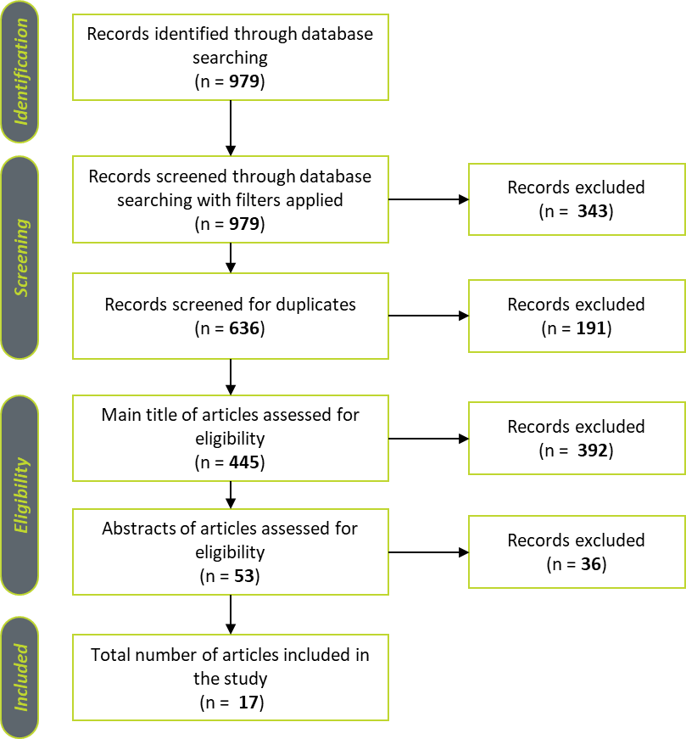

Figure 2.1 – PRISMA Execution

This process resulted in 12 journal articles and 5 conference papers. The publications are summarized in the following table, providing a brief description of each study’s main contributions.
# | Authors | Article | Contribution | Publication Type
[1] | (Arrul et al., 2022) | Predicting the Football Players' Market Value Using Neural Network Model: A Data-Driven Approach | Develops a neural network model optimized through hyperparameter tuning to predict football players' market values based on FIFA 19 data, achieving 96% accuracy | Conference Paper
[2] | (Guo et al., 2024) | Sports Injury Prediction and Prevention: Analysis Methods Based on Big Data and Artificial Intelligence | Introduces a sports injury prediction model using big data and AI that integrates deep learning and random forest algorithms to analyze multi-dimensional athlete data, achieving higher prediction accuracy and enabling personalized injury prevention strategies | Conference Paper
[3] | (Kumar et al., 2025) | Leveraging artificial intelligence and machine learning in sport sciences: a systematic literature review of applications, outcomes, and future directions | Synthesizes 40 studies on AI/ML applications in sports sciences, highlighting high-performance algorithms like CNNs and LSTMs for motion tracking, and SVMs and RFs for workload analysis, identifying key challenges such as algorithm opacity, small homogeneous samples, and limited real-world deployment | Journal Article
[4] | (Mateus et al., 2024) | Empowering the Sports Scientist with Artificial Intelligence in Training, Performance, and Health Management | Presents a framework for applying AI in sports science to enhance training, performance, and health management, while reviewing current techniques, challenges, and future directions | Journal Article
[5] | (McLean et al., 2021) | Who is in control? Managerial artificial general intelligence (MAGI) for Football | Highlights the potential risks of managerial artificial general intelligence (MAGI) in football, emphasizing how its deployment could undermine fairness and autonomy in the sport | Journal Article
[6] | (Pietraszewski et al., 2025) | The Role of Artificial Intelligence in Sports Analytics: A Systematic Review and Meta-Analysis of Performance Trends | Synthesizes 16 peer-reviewed studies across 13 sports disciplines, demonstrating that artificial intelligence (AI) significantly enhances sports performance analysis through improved training optimization, tactical decision-making, and injury prevention strategies | Journal Article
[7] | (Procopiou & Piki, 2023) | The 12th Player: Explainable Artificial Intelligence (XAI) in Football: Conceptualization, Applications, Challenges and Future Directions | Conceptualizes Explainable AI (XAI) for football, showing how it can enhance transparency, trust, and decision-making in areas like scouting, tactics, player development, and injury prevention | Conference Paper
[8] | (Shukla et al., 2024) | Utilizing Artificial Intelligence for Enhancing Performance and Preventing Injuries in Sports Analytics | Proposes an AI-driven sports analytics platform using XGBoost and other AI techniques to enhance player performance and reduce injury risk through individualized, data-driven recommendations | Conference Paper
[9] | (Souaifi et al., 2025) | Artificial Intelligence in Sports Biomechanics: A Scoping Review on Wearable Technology, Motion Analysis, and Injury Prevention | Synthesizes AI applications in sports biomechanics, highlighting methods, effectiveness, and gaps to improve performance and prevent injuries | Journal Article
[10] | (Vallance et al., 2020) | Combining internal and external training-loads to predict non-contact injuries in soccer | Develops a multi-dimensional, non-linear machine learning model that integrates both internal and external training loads to predict non-contact injuries over different time horizons | Journal Article
[11] | (Van Eetvelde et al., 2021) | Machine learning methods in sport injury prediction and prevention: a systematic review | Evaluates the application of machine learning (ML) methods in predicting and preventing sports injuries, highlighting their potential to identify high-risk athletes and key risk factors | Journal Article
[12] | (Wbaid et al., 2025) | Artificial Intelligence-Powered Sports Analytics: Enhancing Performance Through Data Science | Integrates AI-driven machine learning for real-time performance tracking and predictive injury analysis through the ML-PA-IP framework, improving accuracy, reducing injuries, and enhancing data-driven decision-making in sports | Conference Paper
[13] | (Xu & Baghaei, 2025) | Reshaping the future of sports with artificial intelligence: Challenges and opportunities in performance enhancement, fan engagement, and strategic decision-making | Demonstrates how artificial intelligence (AI) technologies, including artificial neural networks and data analysis, can enhance sports performance by providing data-driven insights and predictions | Journal Article
[14] | (Yigit et al., 2020) | An XGBoost-lasso ensemble modeling approach to football player value assessment | Introduces an ensemble machine learning model combining XGBoost and Lasso regression to assess football player value, enhancing transfer decision-making processes | Journal Article
[15] | (Zhang & An, 2025) | Enhancing Sports Team Management Through Machine Learning | Applies machine learning and pruning techniques to identify key player performance attributes and generate predictive insights for match outcomes and expert-style rankings in football | Journal Article
[16] | (Zhou et al., 2025) | Artificial intelligence in sport: A narrative review of applications, challenges and future trends | Comprehensively examines the applications of artificial intelligence (AI) across key domains in sports, including biomechanics, performance enhancement, and sports medicine, highlighting its transformative impact | Journal Article
[17] | (Zhu, 2025) | Design and implementation of an intelligent sports management system (ISMS) using wireless sensor networks | Proposes an Intelligent Sports Management System (ISMS) that combines wireless sensor networks and neural networks to monitor athletes, predict injuries, and optimize training, showing higher accuracy and efficiency than traditional methods | Journal Article
Table 2.5 – Systematic Review’s studies included

PRISMA Results Analysis
Having completed the systematic literature search in accordance with the PRISMA methodology, as detailed in the previous section, the next step involves analyzing the selected articles. This analysis aims to extract the main contributions, conclusions and gaps of each study and to synthesize the findings to address the research questions posed in this study.

SLRQ1 – “What is the current state of research on the application of Artificial Intelligence, particularly Agentic AI, in the field of sports management?”
Most of the literature is strong on predictive analytics that inform management, but thin on truly autonomous, goal-driven “agentic” systems that act on their own – Agentic AI. In practice, today’s tools mostly produce risk scores, rankings, and recommendations that coaches and staff then interpret. Injury-risk modelling is a good example, where models combining internal and external load data improve short vs long-horizon predictions and can highlight which inputs matter [(Vallance et al., 2020); (Van Eetvelde et al., 2021)], but they stop at decision support rather than automated intervention. Newer work that fuses deep learning with random forests across physiological, psychological, workload, and environmental streams shows solid discrimination (AUC ≈ 0.85, good discrimination, meaning the model usually ranks higher-risk athletes above lower-risk ones) and claims downstream reduction in injury incidence when staff use the outputs, again as guidance rather than autonomous action (Guo et al., 2024).
On performance and operations, evidence is strong but mostly laboratory-bound, examples such as CNNs and LSTMs reach ≈96% and ≈92% accuracy for analyzing athletes’ movement patterns, including how they walk, run, and change direction (motion and gait), and pooled accuracies across 13 sports sit near ≈88%, yet only a fraction of systems are tested outdoors, and samples skew within young, healthy and male subjects, causing limitations for club deployment due to different environments [(Kumar et al., 2025); (Pietraszewski et al., 2025)]. Biomechanics scoping review shows tangible management outcomes (e.g., reinjury reduction; sizable gains in coach learning), while flagging the practical blockers that managers face like standardization, interpretability, and embedding models into coaching routines (Souaifi et al., 2025). Practice-oriented and narrative work highlight clear upside in load management, return-to-play, and monitoring, but insist that governance, solid data practices, and concrete rollout plans come first [(Mateus et al., 2024); (Zhou et al., 2025)].
There are topics that touch core management levers. Player valuation models support transfer decisions with high accuracy on historical datasets (e.g., 96% performance prediction accuracy and ≈30% injury reduction with XGBoost-based platforms), offering concrete decision aids for recruitment and budgeting, yet they don’t act autonomously or account for live context shifts without a human in the loop [(Arrul et al., 2022); (Shukla et al., 2024); (Yigit et al., 2020)]. Team-management analytics can reproduce expert-style ratings, surface the attributes that matter by position, and even reach 63% match-outcome accuracy (90% when aggregated at team level), but integration into live match control rooms or auto-updating training plans remains untested (Zhang & An, 2025).
Explainability and governance are active threads because management will not delegate decisions to black boxes. Football-specific XAI work argues for human-centered models to make tactics and injury signals legible to coaches and executives (Procopiou & Piki, 2023). Policy-oriented pieces warn that more powerful managerial AI (even gesturing at “MAGI”) could create unfair advantages and raise ethics and control issues (McLean et al., 2021).
Although Agentic AI is still lightly developed, the foundations for future integration in sport are in place. Systems papers outline full-stack architectures like frameworks with sensor ingestion, business logic, scheduling, analytics and security, that provide the scaffolding for agentic workflows, but current evidence focuses on technical metrics rather than hands-off orchestration in real clubs (Zhu, 2025). Likewise, end-to-end frameworks for performance and injury analytics (e.g., ML-PA-IP) stress real-time tracking and AI recommendations, while explicitly labeling automated, closed-loop actions as a “next step,” not current practice (Wbaid et al., 2025). However, broader reviews still converge on the bottlenecks preventing true agency. Inconsistent data and sensor setups limited real-world validation, demographic biases, weak interpretability and clinical/ organizational integration are the main constraints [(Kumar et al., 2025); (Mateus et al., 2024); (Pietraszewski et al., 2025); (Souaifi et al., 2025); (Van Eetvelde et al., 2021); (Zhou et al., 2025)].
Bottom line, the field has a mature predictive base and credible platform blueprints, with early signs of sports management impact (injury mitigation, workload tuning, talent and performance assessment, knowledge transfer). But “Agentic AI” in the strict sense (autonomous agents that set sub-goals, monitor streams, take actions and are able to auto-adjust session plans, proactively schedule return-to-play progressions, or trigger roster moves and then self-evaluate), is largely aspirational in the current literature. What we actually see are recommendation engines and near-real-time feedback loops awaiting integration into human workflows. To cross the gap, studies consistently point to the same work items: standardize data and evaluation, expand to diverse athlete populations and true field conditions, build explainable interfaces for coaches and managers, and define governance for autonomy and fairness before handing the keys to software [(Guo et al., 2024); (Kumar et al., 2025); (Mateus et al., 2024); (McLean et al., 2021); (Pietraszewski et al., 2025); (Souaifi et al., 2025); (Wbaid et al., 2025); (Zhang & An, 2025); (Zhu, 2025)].

SLRQ2 – “What are the key challenges and limitations associated with the implementation of Agentic AI in sports management?”
Agentic AI needs clean, real-time data and the mandate to act, not just advise. Today, the bottlenecks are clear. Data fragmentation and missing standards remain a primary concern, as sensor setups, features, and evaluation protocols vary wildly, creating difficulties to implement agents. Reviews repeatedly call for standardized schemas and pipelines, with valuation work noting multi-season data gaps and compute hurdles [(Kumar et al., 2025); (Mateus et al., 2024); (Pietraszewski et al., 2025); (Souaifi et al., 2025); (Van Eetvelde et al., 2021); (Zhou et al., 2025); (Arrul et al., 2022)]. External validity is weak, as many results are developed under controlled-environment settings, only a fraction of systems were tested outdoors (Kumar et al., 2025), and a meta-analysis shows extreme heterogeneity, meaning that study results vary widely and are inconsistent across different samples or contexts, warning against easy transfer across teams or sports (Pietraszewski et al., 2025). Cohorts are often narrow, such as one elite male squad over a season, and lack long-term or diverse validation [(Vallance et al., 2020); (Guo et al., 2024); (Shukla et al., 2024); (Wbaid et al., 2025); (Zhu, 2025)].
The autonomy gap means today’s systems advise but don’t act. They output scores or recommendations, yet they don’t automatically adjust training loads or schedules in real time; those closed-loop controls are still “next step” items (Wbaid et al., 2025). Even when headline results look strong, changes are still executed by staff rather than software (Shukla et al., 2024). Live, production integrations are scarce or untested [(Guo et al., 2024); (Zhang & An, 2025)], coaching deployment effects are rarely evaluated (Vallance et al., 2020), and systems papers emphasize technical metrics over autonomous club-level orchestration (Zhu, 2025). Meanwhile, explainability and trust remain blockers, teams still won’t delegate to opaque models, hence the push for football-specific XAI and human-centered explanations [(Kumar et al., 2025); (Mateus et al., 2024); (Van Eetvelde et al., 2021); (Procopiou & Piki, 2023)].
Governance, privacy, and fairness concerns span competitive equity, particularly who controls "managerial AI", alongside data privacy, bias, and equitable access, creating barriers to granting agents decision rights until rules and safeguards are clear [(McLean et al., 2021); (Zhou et al., 2025); (Shukla et al., 2024); (Souaifi et al., 2025); (Xu & Baghaei, 2025)], creating a need for supervising its decisions. Scale, cost, and skills present additional challenges, as compute costs, data variability, and unproven scalability under heavy, multi-sport loads slow rollout. Authors ask for stress-testing and broader deployments, plus AI-literate staff and tighter AI-sport-science collaboration [(Wbaid et al., 2025); (Zhu, 2025); (Mateus et al., 2024)]. Inconsistent metrics and benchmarks, such as accuracy (out of X guesses, how many were right) versus AUC (how good it was sorting the risky players to the top of a list) versus F1 (number that balances precision and recall), also hamper certification for production use [(Pietraszewski et al., 2025); (Van Eetvelde et al., 2021)]. Small but telling frictions persist: some injury models omit crucial context like weather or accumulated fatigue (Vallance et al., 2020), and some valuation models learn seasonal form but not match-day dynamics (Arrul et al., 2022), all important gaps that matter for agents making daily adjustments.
Bottom line, it results in a system with strong prediction but weak autonomy. Getting to agentic systems means standardizing data and evaluation [(Kumar et al., 2025); (Pietraszewski et al., 2025); (Souaifi et al., 2025); (Zhou et al., 2025)], field-testing on diverse cohorts [(Guo et al., 2024); (Pietraszewski et al., 2025); (Vallance et al., 2020); (Zhu, 2025)], deliver XAI interfaces for coach trust [(Kumar et al., 2025); (Procopiou & Piki, 2023); (Van Eetvelde et al., 2021)], setting governance on privacy and fairness [(McLean et al., 2021); (Shukla et al., 2024); (Zhou et al., 2025)], and engineering real-time, closed-loop control at club scale [(Wbaid et al., 2025); (Zhang & An, 2025); (Zhu, 2025)].

SLRQ3 – “Which Artificial Intelligence and Agentic AI techniques are currently being applied in sports management and how effective are they in addressing domain-specific needs (e.g., analytics, injury prediction, performance management)?”
Performance analytics and movement analysis are dominated by deep neural networks, with CNNs achieving approximately 96% accuracy for motion and gait analysis and LSTMs reaching around 92%, both delivering sub-100 ms feedback [(Kumar et al., 2025); (Pietraszewski et al., 2025)]. In simple terms, these systems can very quickly and accurately monitor athletes’ movements, providing near-instant insights that can guide training and injury prevention.
Pooled accuracy across 13 sports stands at approximately 88% (Pietraszewski et al., 2025). In practical applications, computer vision systems operate within 15 mm of marker-based systems, while AI-driven training plans have improved technique metrics by ≈25%, reduced reinjury rates by ≈23%, enhanced coach learning by 45% and athlete adherence to prescribed training programs by a factor of 3.4 when embedded in training routines (Souaifi et al., 2025).
Injury prediction and health monitoring rely heavily on multimodal approaches, with models combining deep learning and random forests across physiological, psychological, workload, and environmental data achieving AUC values of approximately 0.85 and demonstrating lower injury rates when staff act on their outputs (Guo et al., 2024). Random forests predict hamstring injuries at roughly 85% accuracy (Souaifi et al., 2025). Load-aware machine learning reveals that internal-load signals are most effective for one-week risk prediction, while combining internal and external loads proves superior for monthly forecasts, supporting practical planning cycles (Vallance et al., 2020). A synthesis of results reports model performance in terms of injury prediction accuracy and classification metrics ranging from poor to strong, with top models reaching AUC 0.87 and F1 scores of 85%, while emphasizing the need for interpretability in clinical contexts (Van Eetvelde et al., 2021). Some XGBoost platforms report approximately 96% performance prediction accuracy and ≈30% injury reduction following adoption (Shukla et al., 2024).
Talent identification, valuation, and team decision support utilize player-value models that perform well on historical data, with neural networks achieving ≈95% accuracy and XGBoost-Lasso approaches validated across 11 leagues to inform transfer decisions [(Arrul et al., 2022); (Yigit et al., 2020)]. Team analytics reproduce expert ratings and identify position-critical attributes, while match prediction accuracy sits at approximately 63% at the individual level but reaches ≈90% when aggregated to team-level assessments, supporting selection and tactical discussions (Zhang & An, 2025). Agentic AI elements are emerging through end-to-end stacks such as ML-PA-IP and ISMS frameworks that connect sensors to data pipelines, analytics, and user interfaces, posting strong technical KPIs including accuracy of 0.94 and specificity of 0.97 [(Wbaid et al., 2025); (Zhu, 2025)]. However, these systems typically recommend rather than autonomously execute actions, with explainable interfaces being developed to build coach trust (Procopiou & Piki, 2023).
Important contextual considerations temper these findings. Validation frequently occurs in controlled settings or narrow cohorts, particularly young, healthy males, with outdoor and real-world testing less common, limiting claims of generalization despite otherwise solid performance metrics [(Kumar et al., 2025); (Pietraszewski et al., 2025)]. Nonetheless, the foundational building blocks are established, with accurate sensing and analysis capabilities, interpretable models where required, and integrated system stacks capable of hosting agent behaviors under human control [(Kumar et al., 2025); (Mateus et al., 2024); (Procopiou & Piki, 2023); (Wbaid et al., 2025); (Zhu, 2025)].

Key Takeaways
Across the three research questions, a clear pattern emerges: while AI in sports management excels in perception and prediction, it still lacks autonomy, with limited signs of truly Agentic AI in practice. Deep nets (CNN/LSTM) reliably quantify movement and drive fast feedback; tree ensembles and boosting flag injury risk and support valuation and selection with credible accuracy; integrated stacks with systems like, sensors data analytics UI, are in place to host more agentic workflows. Yet most deployments still advise rather than act. The blockers are well known, with fragmented data and protocols, laboratory-based validation with narrow cohorts, opaque models, and unresolved governance around privacy, bias, and competitive equity being the most relevant ones. The road to success is defined and it has a clear path ahead. By standardizing data and evaluation, proving generalization in the field with diverse squads, delivering explainable interfaces coaches will use, and introducing controls gradually under human oversight, “agentic” AI can transition from a promising concept to practical, operational use.

Methodology

Overview
This chapter outlines the methodological approach adopted throughout the research, serving as a roadmap for the study’s development. It structures the subsequent phases to maintain a clear and logical progression, ensuring that each stage connects coherently to the next. A primarily qualitative approach, complemented by analytical evaluation, is employed to address assessment of models and workflows and provide a comprehensive understanding of the topic, from conceptual exploration to applied analysis.
As illustrated in Figure 3.1 – “Phases of the Methodology”, the research unfolds through a sequence of four interdependent phases, each comprising distinct yet complementary steps that guide the study toward the formulation and evaluation of an Agentic AI workflow and its potential impact within the sporting context.

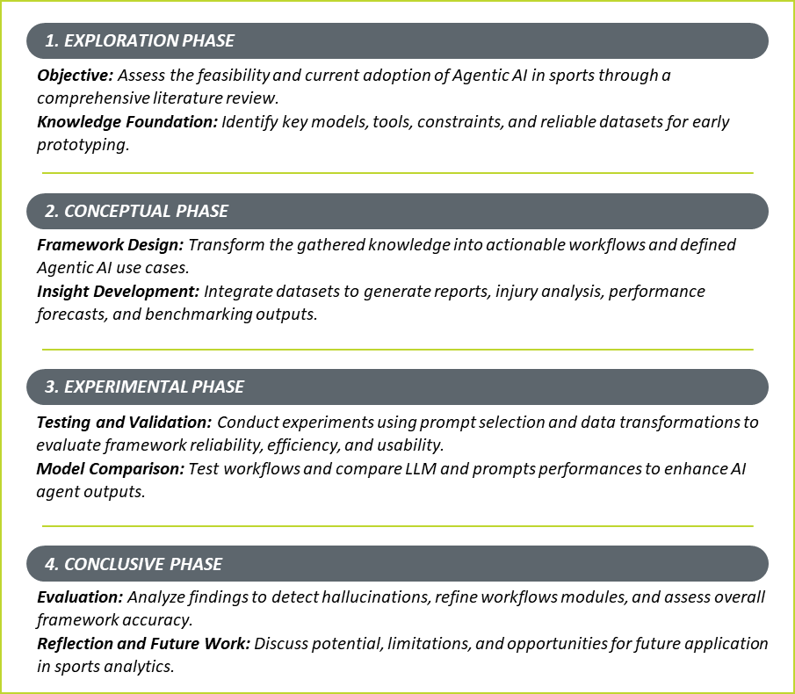
Figure 3.1 - Phases of the Methodology

Exploration Phase
The exploration phase begins with a comprehensive literature review to assess the feasibility of applying Agentic AI in sports and to understand the current state of technological adoption in the field. This stage establishes a conceptual foundation of Agentic AI principles, available models and software solutions, along with their constraints and challenges, while identifying reliable datasets suitable for preliminary prototyping. It also reviews past applications to identify successful and unsuccessful approaches, informing the definition of expected outputs and the procedural behavior of the proposed system.

Conceptual Phase
The conceptual phase focuses on translating the knowledge gathered during exploration into actionable insights for developing Agentic AI workflows and use cases. This stage integrates the selected datasets to test and understand data requirements for generating key insights: 1) Weekly performance reports that enable continuous risk and performance monitoring with scalable week-to-week analysis; 2) Injury likelihood analysis based on load and key physiological conditions, supporting personalized recovery and training plans; 3) Benchmark results against a former professional player biometric datasets, and provide narrative reports combining medical, physical, and performance data; 4) Performance forecasting to inform player valuation and data-driven decision-making.
The primary goal is to design an accessible, low-resource framework that leverages Agentic AI to deliver these insights and benchmark results against existing studies. This design prioritizes interpretability, ensuring that non-technical stakeholders can engage with complex outputs clearly and effectively.

Experimental Phase
The experimental phase consists of a series of tests focusing on prompt selection and data transformation processes (such as models and feature selection, index accuracy and development) to evaluate the feasibility and performance of the proposed framework. The assessment focuses on key dimensions such as reliability, accessibility, ease of use, and overall efficiency. Outcomes are analyzed from two perspectives: the player side, by verifying whether generated results align with known ground truths, and the management side, by assessing usability and the added value of adopting these tools.
During this phase, the developed workflows are tested to identify potential improvements and to compare the performance of different models and large language models (LLMs) in supporting AI agent behavior and output quality.

Conclusive Phase
In the final phase, findings from the previous stages are analyzed to identify potential LLM hallucinations and unexpected outputs during workflow development. The artifacts produced are critically assessed to refine workflows modules and prompts and improve the overall accuracy and consistency of the AI modules.
This evaluation validates the framework’s efficiency and ensures the generated insights meet expectations. The research concludes by reflecting on the framework’s potential, resource demands, and practical value, establishing it as a foundation for future work in Agentic AI within sports analytics.

Experimental Design – Agentic ai framework
This chapter presents the design and development of the analytical framework created to implement and evaluate multiple AI-driven workflows. The framework is organized into three distinct yet complementary workflows, each tailored to run specific functions across different contexts. A structured, step-by-step approach will be used to describe the design process, from conceptualization to module integration and workflow automation.
The implementation relies on Make (AI & Automation Platform) as the main orchestration tool, enabling efficient connectivity between components, where the scenarios for workflows and AI Agent are built. Each workflow module is detailed to show how specific tools and integrations enhance performance and adaptability. Once deployed, the framework runs autonomously in the background, continuously ingesting and storing data for longitudinal analysis while computing key performance indicators. The resulting AI-generated outputs are presented through a centralized web platform offering insights, reports, and automated alerts.
This methodology provides a holistic evaluation of AI assisted solutions using emerging technologies, such as AI Agents. Designed for accessibility and scalability, allowing modules to be added or removed as needed, the framework can be implemented by teams with varying resources, yielding deeper insights and more accurate results as more capacity becomes available.

Datasets
The workflows will rely on three main different datasets for training, preparation and historical data collection, and two additional sample-down data sets will be made for testing purposes. The datasets will be obtained from the Kaggle datasets library to address the workflows purposes. The three main datasets include:
- Weekly Report & Injury Risk – A dataset containing weekly NFL player statistics from a previous season (e.g., snaps, targets, playing surface, etc.) focused on Cornerbacks and Safeties. It includes engineered features such as fatigue index and defensive effort, enabling the system to assess physical load and flag short-term injury probability for defensive backs, positions characterized by high intensity demands, frequent changes in direction, acceleration, and endurance.
Use cases: Workflow 1 & 2
- Benchmark Health and Performance Measures – A dataset built from former NFL defensive back Justin Hilliard’s biometric data, used to define optimal performance baselines, calibrate alert thresholds, and generate tailored training and nutrition recommendations. The dataset integrates information from multiple devices such as Oura Ring (sleep), Whoop and Polar (training and recovery), and MyFitnessPal (nutrition), to capture comprehensive insights into performance, recovery, and readiness. It aims to identify periods when the athlete performed at peak condition and, later, to support personalized reports that highlight improvement areas for enhanced performance and recovery.
Use case: Workflow 2
- End-of-Season Performance Projection – A dataset composed of multi-season historical statistics from NFL offensive players (Wide Receivers and Running Backs). By cross-referencing game data with NFL PPR scoring and prior-season metrics, the system forecasts player trajectories, predicting whether an athlete’s performance indicators suggest improvement, stagnation, or decline for the upcoming season. This provides an analytical baseline for evaluating expected value and performance potential.
Use case: Workflow 3
For a clearer overview of the datasets utilized, please refer to Appendix A (Tables 1 to 3), which detail the features and parameters employed throughout the framework’s development.

Agentic AI Framework
The development of the proposed Agentic AI framework builds on the literature review, which revealed that no prior studies have directly explored Agentic AI in sports. Because of this gap, several components of the framework had to be created through practical experimentation and iterative testing to identify an effective and scalable workflow structure. Even so, the literature provided essential foundations, including working predictive models for injury forecasting, player valuation, and performance monitoring, as well as conceptual architectures for sensor data ingestion, analytics pipelines, and data security.
The reviewed studies also highlighted persistent challenges, such as data fragmentation, lack of standardization, and limited system autonomy, which similarly emerged during the framework’s development. Addressing these issues shaped the need for a more integrated and agent-driven workflow.
A central requirement in designing the workflows was integrating domain knowledge on how sports injuries develop and how this logic should function within an autonomous decision system. As Bittencourt et al. (2016) highlight, injuries stem from multifactorial and non-linear interactions across physiological, psychological, and contextual factors. Susceptibility is influenced by variables such as age, sex and BMI (Zadeh et al., 2021), while internal load responses, such as heart rate, breathing rate, training stress, and energy expenditure, also shape tolerance and recovery capacity. Psychological variables, including anxiety, stress, sleep quality, and mental state, further affect injury likelihood and recovery (Clemente et al., 2021). Recognizing these interacting domains was essential for ensuring that the framework’s logic incorporated multi-dimensional inputs, operationalized through the “Benchmark Health and Performance Measures” dataset.
The workflow design further incorporated relevant GenAI development principles, including those presented in Fernandes’ study, as well as widely accepted industry best practices.
Another key gap identified in the literature is the inability of existing systems to adjust training plans, intensities, or recovery schedules in real time. This limitation is directly addressed in the framework, where the system autonomously generates tailored reports with training and recovery plans for flagged players, representing a meaningful step towards Agentic AI systems.
Finally, aligning with the PRISMA review’s identification of missing explainable interfaces for coaches and managers, the project incorporates the development of a dedicated web-based team management platform. This platform ingests, contextualizes, and presents all workflow outputs in an interpretable format, enabling practical and responsible use of autonomous decision-making. In doing so, the project moves beyond the theoretical foundations established in earlier chapters and toward a fully operational implementation.
Framework Design
To support this transition from conceptual understanding to practical implementation, it was necessary to establish a set of foundational design principles that would anchor the framework throughout development. As previously noted, scalability emerged as a central requirement, ensuring that even as individual workflows evolve or new modules are introduced, the core structure of the system remains consistent, reusable, and adaptable to different sports contexts.
To operate the Agentic AI Framework, a master workflow was developed to configure and orchestrate the AI agent. This master process governs autonomous and on-demand executions, based on predefined set of rules. Its main purpose is to provide the agent with controlled access to essential tools, available workflows, and the operational playbook, defining how the agent should behave and respond to given inputs.
The AI Agent operates autonomously, executing scheduled tasks across predefined workflows while also allowing manual activation when specific scenarios need to be triggered. It can access, execute, and manage selected workflows by ingesting relevant inputs, processing them through defined logic, and generating structured outputs. This dual capability, automated scheduling combined with on-demand execution, ensures flexibility, adaptability, and continuous operational efficiency within the system.

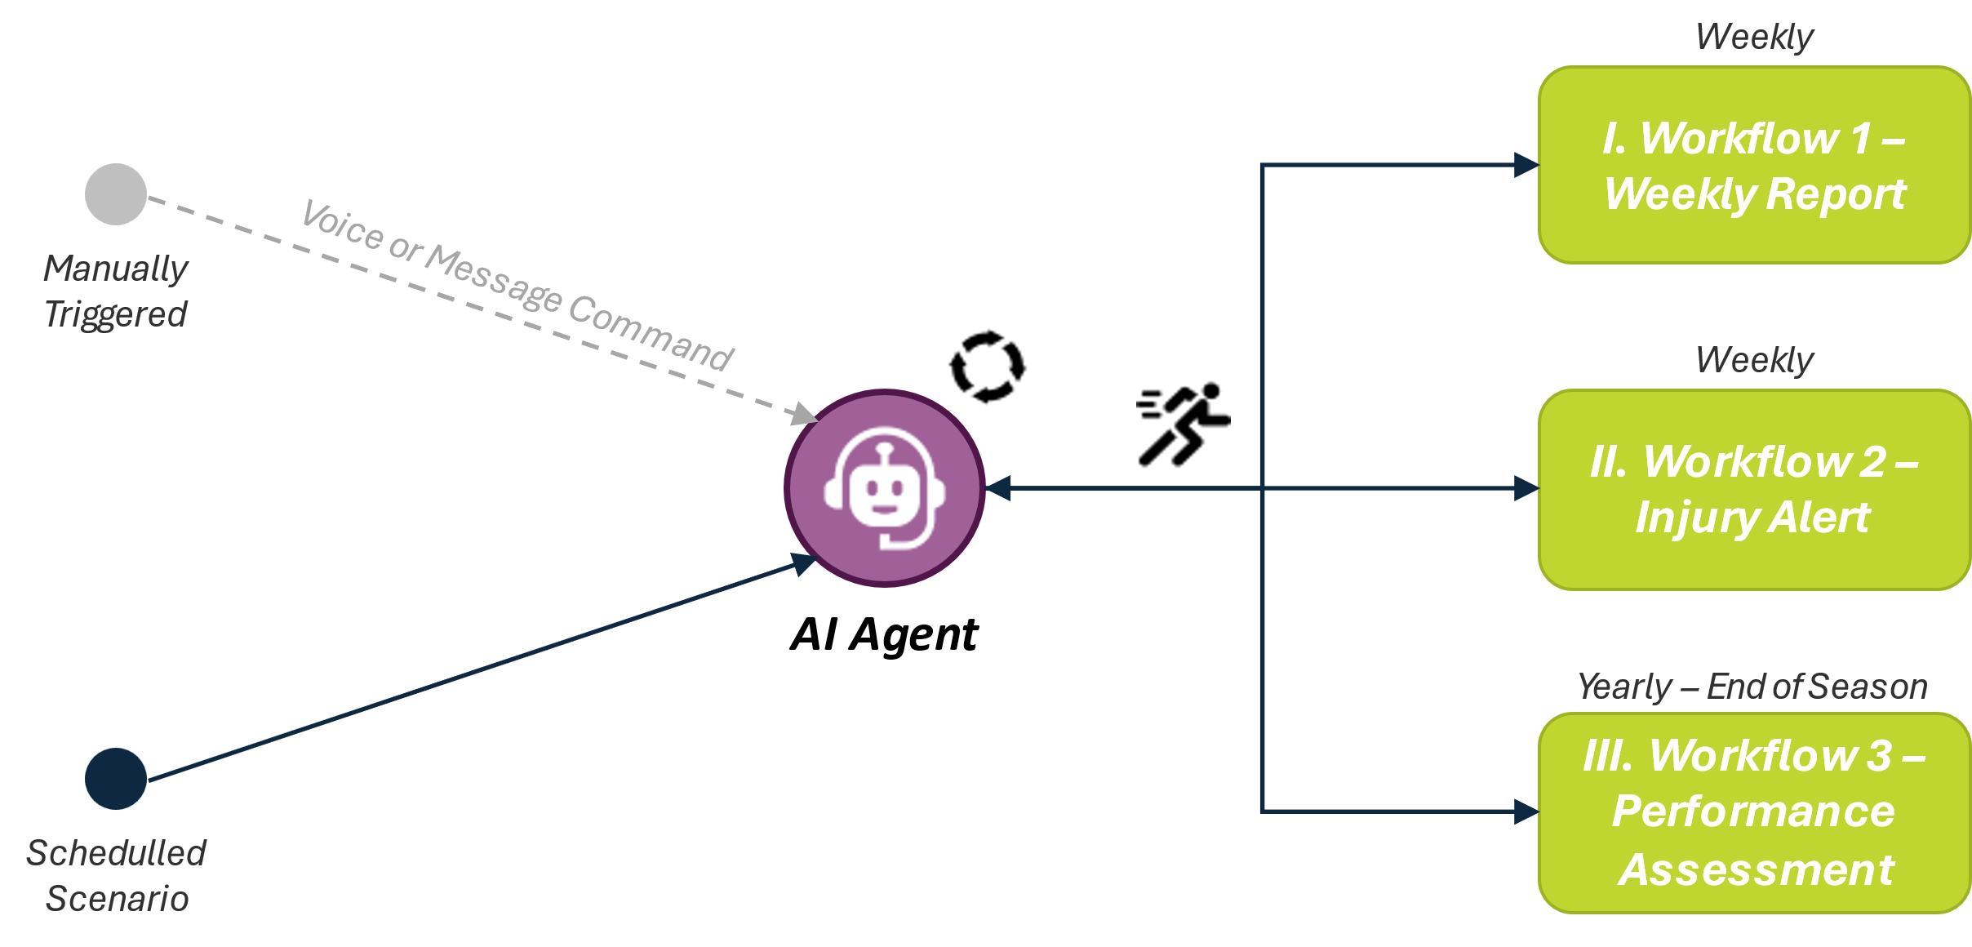

Figure 4.1 – Agentic AI Master Workflow

After defining the AI Agent Master workflow, the next step is to outline the development framework that establishes the rules and structure all workflows will follow, ensuring consistent support and operationalization of the main process.
The core workflows were built upon the foundations described earlier, starting with data ingestion and transformation phases, where records are collected, cleaned, and transformed. This includes database transformations, text aggregation, and the removal of entries to ensure that data is standardized and ready for AI module consumption.
Following data preparation, the AI Processing Phase executes. Here, AI modules analyze the processed data, applying personalized prompts to generate insights, predictions, and analytical outputs based on underlying models, datasets, and contextual rules embedded within each prompt.
Once the analytical processes are completed, results move through the routing and branch logic phases. In this stage, workflow logic determines the appropriate pathways for each output, deciding how insights are formatted and published, and then stored for historical tracking and future analysis.
Finally, the scheduling and execution control phase automates operational cadence. This includes defining when and how often each scenario runs, whether triggered by the AI agent or scheduled periodically. Continuous monitoring mechanisms are embedded within this layer to track performance, detect errors, and flag anomalies such as execution failures, bugs, or potential AI hallucinations, ensuring consistent reliability of the entire framework.

Figure 4.2 – Framework Key Foundations

Workflow 1 – Weekly Report
This is the simplest of the three core workflows developed, designed to generate weekly reports on player performance by analyzing game statistics, effort metrics, and overall team chemistry and outcomes. Its primary objective is to provide consistent, data-driven insights into player workload and performance fluctuations throughout the season, with an easy-to-read report.
The workflow operates on a weekly scheduled basis, with the possibility of being manually triggered, leveraging the “Weekly Report & Injury Risk” (Defensive Backs) dataset described earlier. This dataset tracks key in-game metrics across multiple weeks, enabling the system to quantify individual load patterns, detect outliers, and highlight performance peaks.
Composite indices
To facilitate cross-player comparisons, two composite indices were developed, each built using weighted parameters to assess distinct aspects of performance.
The Defensive Effort Index quantifies a player’s defensive performance by combining weighted game statistics such as tackles, sacks, hits, interceptions, games played and defensive and special teams participation, normalized against the maximum attainable values for each metric. The formula applies a square root transformation to smooth extreme values and introduces modifiers accounting for consecutive weeks played, which reflect physical resilience and sustained and cumulative workload. This index is effective because it merges performance volume and contextual effort, providing a fair, comparative measure of defensive intensity across players and time periods.
The Fatigue Index estimates accumulated physical strain based on age, body composition (BMI), total games and past injury historic, combined with the Defensive Effort Index. Each factor is categorized into progressive risk tiers, where higher age, BMI, or workload contribute incrementally to the overall fatigue score, producing a normalized value between 0 and 1. This index is valuable as it integrates both physiological and workload dimensions, offering a simple yet robust indicator of potential overexertion or need for recovery management.
Together, these indicators offer a structured way to monitor player condition, flag possible injury risks over time, and compare player performance.
These indexes serve as key reference metrics, allowing the system to standardize and compare player performance values when ingested by the AI module. Their primary purpose is to support interpretation and comparative assessment of player effort, not to perform prediction or trend analysis. At this stage, the workflow operates through descriptive, rule-based analysis, where the AI interprets and summarizes existing data patterns without applying machine learning or forecasting techniques.
The indexes are pre-defined within the underlying database, enabling automatic calculation upon data entry. Once the dataset is updated and stored, the system computes the indexes in real time, ensuring that all subsequent operations access up-to-date and standardized values.
Scenario
Following data ingestion and transformation phases (including loading, cleaning, and text aggregation), the structured dataset is converted into textual input and passed to the OpenAI module, selected based on the balance between cost and prompt completion quality. Different model versions were tested (namely o4-mini, GPT-4.1, and GPT-5, with additional benchmarking against Sonar (Perplexity) and Sonnet 4.5 (Claude) models) to identify the best performance-to-cost configuration, with GPT-4.1 ultimately emerging as the most used model.
The OpenAI module operates through structured prompts developed according to Fernandes’ study and Lin’s (2023) guidelines in “Ten Simple Rules for Crafting Effective Prompts for Large Language Models.” These prompts are carefully designed with explicit instructions and clear expectations regarding the desired outputs.
Each week, the module receives a text input containing all relevant player data, including statistical measures and index values, corresponding to the period selected by authorized managers and staff. Upon execution, the selected model analyzes the data to generate concise and professional weekly reports. These reports summarize team performance, flag potential fatigue risks, and provide recommendations for workload adjustments. After defining the system’s core behavior, the following guiding principles were established:
- Identify top and underperforming players and detect performance trends (e.g., frequency of overperformance or underperformance).
- Suggest rest periods, reduced training loads, or workload management interventions when the Fatigue Index hits an established threshold (e.g., above 0.79).
- Maintain a team-focused analytical approach, emphasizing collective insights while spotlighting individual players only when necessary.
Once generated, the reports are automatically published on the team’s internal platform, allowing coaching and performance staff to easily review the current team status. This automated process enhances decision-making efficiency by combining AI-driven insights with human expertise, ensuring a balanced, data-informed assessment of player performance and health.
Furthermore, as this workflow runs on a weekly basis and share a common dataset from the subsequent “Workflow 2 – Injury Alerts”, it automatically triggers and executes that workflow to ensure data continuity and seamless operational integration, generating both outputs within minutes.

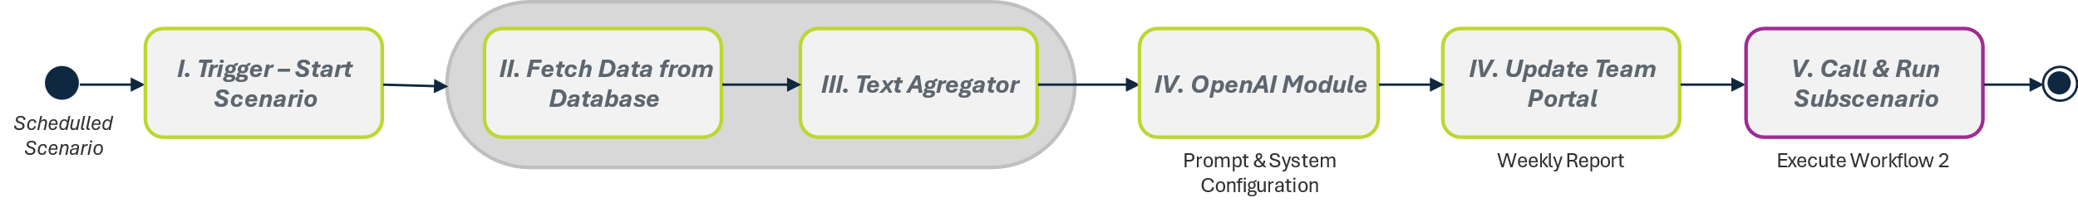
Figure 4.3 – “Workflow 1 – Weekly Report” Key Modules

Workflow 2 – Injury Alerts
Among the three workflows, this is the most complex and most rigorously assessed. It targets injury and fatigue-related risk through AI-driven decision flows. The pipeline consumes quantitative evidence (precomputed indices, players weekly statistics, and contextual variables) and returns an interpretable note for staff to support week-to-week triage.
The objective is to issue weekly alerts for players exhibiting elevated fatigue or unusual load patterns, enabling proactive load management rather than reactive response. Outputs include a tailored summary per player (likely cause, suggested recovery focus, brief history) delivered in a staff-ready format and a full detailed report with additional information for dedicated personnel.
Similar to “Workflow 1 – Weekly Report”, this workflow applies the same analytical structure to the Weekly Report & Injury Risk (Defensive Backs) dataset, which compiles weekly performance, workload, and contextual metrics for NFL defensive backs across both the regular season and playoffs. In addition, it integrates the “Benchmark Health and Performance Measures dataset” of Justin Hilliard, used as a reference for health guidelines and threshold values. These benchmarks help calibrate individualized recovery plans, identify nutrition deficits and areas for improvement in players’ overall performance and well-being.
Following the preliminary data analysis, the modeling phase was initiated using the first dataset. Since reliable binary injury labels (“Yes” or “No” predictions, e.g., “Player X tore his ACL in Week 9”) were not available, traditional supervised prediction methods were not suitable. The study by Rossi et al. had previously demonstrated strong results using an interpretable decision-tree classifier and identified key constraints to address for improved performance. Similarly, the PRISMA-based review also highlighted promising supervised models such as XGBoost for injury prediction tasks. However, because these approaches depend on labeled injury data, which were unavailable in the current dataset, it was not possible to reproduce or extend their methodologies. Therefore, an unsupervised learning strategy was tested instead, modeling each player’s baseline over time and flagging deviations or outliers (particularly those involving unusually high workloads or outlier performances) as potential risk indicators. This approach aligns with prior workload risk research, which supports learning normal behavioral patterns and emphasizing departures from them when labeled outcomes are not accessible.
The dataset (≈3,500 weekly player entries) is moderate in size, causing aggressive subsampling or complex temporal partitioning to possibly induce overfitting (learning idiosyncrasies) or underfitting (missing meaningful structure). Accordingly, the modeling emphasizes stability and player-normalized comparisons.
To better identify injury-related patterns on a per-player, per-week basis, the system generates a risk score aligned with proxy indicators that approximate the likelihood of injury occurrence. These proxies are signals available in data that correlate with physical issues but are not clinical labels (e.g., sudden snap-count drops, DNP/ limited practice notes, questionable/ inactive status, unexpected role changes, short-term absences). They anchor interpretation while acknowledging the lack of confirmed medical outcomes.
Using Python and its core data-science libraries, the Isolation Forest algorithm was implemented to anomalous or irregular behaviors compared to normal baselines in weekly player data. This method was selected because, as previously discussed, it aligns closely with the problem requirements. Isolation Forest detects anomalies by randomly partitioning the dataset, because observations that are easier to isolate require fewer splits, resulting in shorter path lengths and, consequently, higher anomaly scores (Liu et al., 2008). This enables the model to identify unusual deviations in player workload and performance patterns, effectively capturing potential risk signals without the need for predefined labels.
After model configuration and development, the resulting outputs will be compared by aligning the indices explained in the previous workflow with the Isolation Forest model’s anomaly scores. In the absence of confirmed injury records, two proxy indicators were developed to approximate injury events. The first, “pre-gap”, identifies weeks after which a player’s next game occurs more than one week later, excluding scheduled bye weeks, and when the returning snap percentage drops by at least 50% relative to the season average, suggesting a possible injury-related absence. The second, “pre-injury-flip”, captures weeks when the variable previous_injury (field from the dataset describing existing past injury) changes from “None” to any different category and remains so for at least one additional week, indicating a likely new injury report entry.
If the model performs effectively, weeks preceding these proxy events should exhibit higher average risk scores and more frequent high-risk flags, meaning that before an absence in the game sheet the risk would be at its highest. This approach follows a common practice of using measurable substitutes for outcomes that cannot be directly observed. Here, proxies serve as practical stand-ins for verified medical injury data, enabling the system to infer probable injury occurrences from observable behavioral and performance patterns, such as extended absences or abrupt reductions in game participation.

Following the model execution and comparative evaluation between the individual indices (Indices_only), the Isolation Forest outputs (IF_only), and their combined results (IF_plus_indices), these proxy-based indicators served as the basis for assessing the model’s effectiveness in detecting likely injury patterns from the available data.
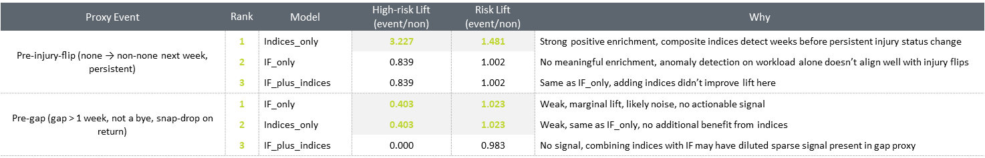
Figure 4.4 – Model Performance & Results

The model performance was evaluated using two complementary metrics: High-Risk Lift and Risk Lift. Lift measures how much better the model performs than random chance, for example, a value above 1 means the model provides useful signals, while a value near 1 means no improvement. High-Risk Lift shows how often the model’s warnings appeared before likely injury events (such as week absence or abnormal reduction in snaps played), and Risk Lift compares the average risk scores before injury-related weeks to those during normal weeks. Together, these measures indicate both how timely and how strong the model’s injury risk detections were. Models were first ranked by High-risk lift, with ties resolved using Risk lift, giving preference to the model with the higher value.
For injury-flip events, the Indices-only model clearly outperformed the others, achieving a 3.23× improvement in identifying high-risk periods. This supports previous findings showing that indices directly related to load and exertion, such as defensive effort and fatigue index, capture physiological strain that often precedes injury status changes. In contrast, the Isolation Forest model treats any deviation from a player’s baseline as equally important, which may lead to false alerts caused by normal performance variations. When combined with indices, this effect can even reduce sensitivity to meaningful spikes in load or fatigue.
For pre-gap events, none of the models showed strong predictive improvement, likely due to the diverse reasons players miss games and the inherent uncertainty of using proxy-based injury signals. Overall, the unsupervised Isolation Forest approach effectively detected deviations from individual performance baselines and produced interpretable per-player risk profiles, but its consistency with proxy events was moderate, reflecting and emphasizing the broader understanding that sports injuries are multifactorial and rarely caused by a single variable (Bittencourt et al., 2016).
Based on these results, anomalies resembling injury probability will be flagged using the calculated composite indices only, ensuring that the monitoring process remains grounded in metrics most closely tied to workload and physiological strain.
Scenario
After defining the approach for how data should be assessed by the AI module, the workflow configuration was developed following the framework outlined earlier in this chapter. The process began by setting up the modules responsible for data ingestion and transformation, integrating two main datasets: the “Weekly Report & Injury Risk” (Defensive Backs) dataset and the “Benchmark Health and Performance Measures” dataset of Justin Hilliard, together with a secondary, down sampled version of the first dataset that simulates current-season statistics using the same parameters. Each week, authorized staff select the target period, and the system automatically compiles a text input containing all relevant player data like statistical measures, contextual information, and index values, similar to the before described workflow (if manually triggered). Before processing, data undergoes validation, normalization, and formatting to ensure that the AI module receives clean, structured input consistent with the previously defined schema.
The prepared data is then analyzed by the OpenAI module, configured to identify players at elevated risk of injury or underperformance. The module primarily focuses on fatigue and effort indices while integrating other statistical variables to produce a standardized output for each flagged player. This structure allows the outputs to be directly integrated into automated alerts and reports without requiring manual adjustments.
Once the analysis phase is completed, the workflow divides into two operational branches:
- The first branch creates a dedicated database to store weekly injury alerts, summarizing essential information such as player name, probable injury/ fatigue cause, severity, description, and recovery recommendations. This database feeds directly into the team management portal, providing staff with quick access to ongoing risk assessments and enabling rapid intervention when necessary.
- The second branch automatically generates a detailed report using a dedicated OpenAI module to provide insights for each flagged player, containing deeper contextual findings, recent and past performance history, and index trends. These reports are sent directly to the medical and performance teams, supporting informed decision-making and facilitating follow-up actions.
Finally, all generated information, both summary alerts and detailed reports, is stored in a season-level historical repository designed for long-term tracking. This archival structure enables longitudinal analysis of player performance and injury patterns, providing valuable historical insights for future workload management strategies. By ensuring a seamless flow from data ingestion to AI-driven interpretation and structured output generation, the workflow delivers both real-time decision support and enduring analytical value for team management and medical staff.
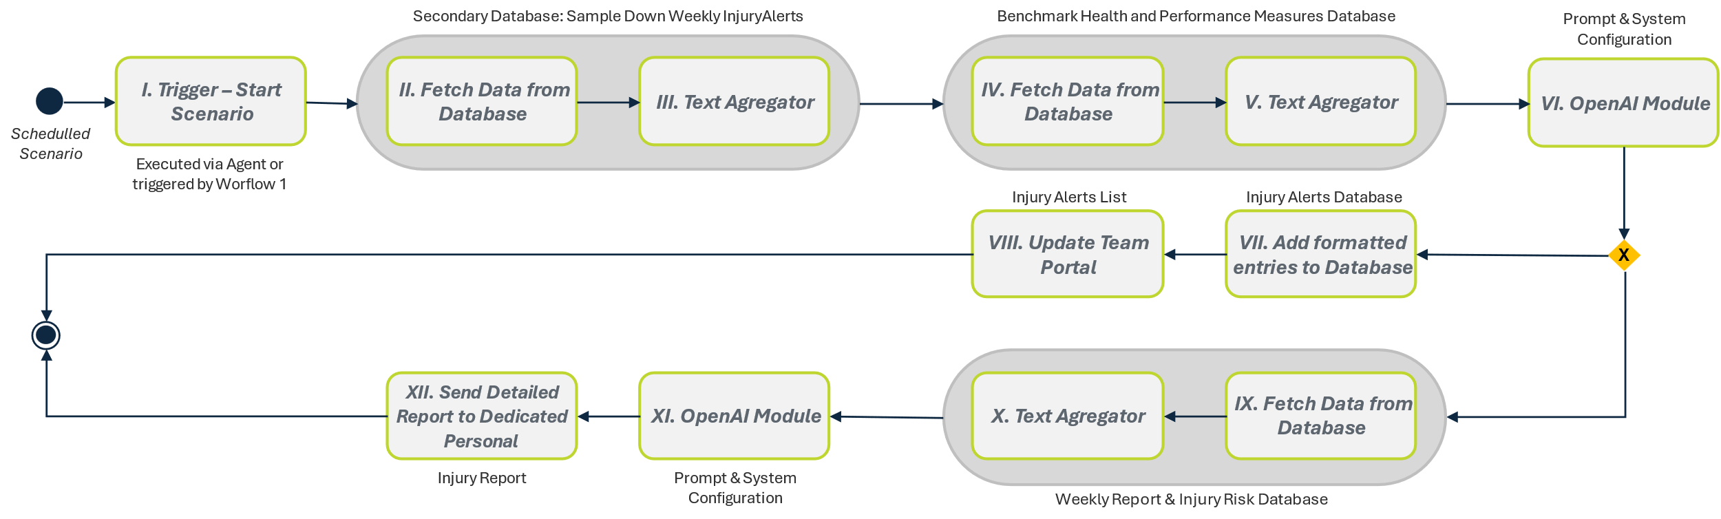
Figure 4.5 – “Workflow 2 – Injury Alerts” Key Modules

Workflow 3 – Performance Assessment & Projection
The rationale behind this workflow is to establish a data-driven mechanism capable of generating an updated team overview and individual in-depth analysis of predicted player performance by systematically comparing seasonal data and identifying recurring patterns or trends indicative of performance variation.
Following the framework previously defined for the workflows that support the AI Agent, this process enables longitudinal analysis of player development over time, highlighting key statistical changes that may signal improvement, stagnation, or regression.
In parallel, a team-level analytical component is incorporated to assess the collective impact of individual players on overall team outcomes. This enables a strategic evaluation of roster composition, supporting managerial decisions on which players to retain, trade, or release. By distinguishing consistent high performers from those exhibiting sustained performance declines, the system contributes to maintaining an optimized and competitive roster.
Regarding the workflow itself, it operates on a yearly schedule, with the flexibility of being manually triggered, and leverages the “End-of-Season Performance Projection (Offensive Players)” dataset introduced earlier. This dataset aggregates multi-season statistics, facilitating longitudinal and comparative analyses. Similar to the other workflows, an evaluative index underpins the analysis by quantifying each player’s contribution to team performance. The index – Team Contribution – integrates key offensive indicators, such as total yards, touchdowns, receptions, and efficiency ratios, adjusted by position-specific weightings (for wide receivers and running backs). It also applies penalties for negative outcomes, including fumbles and interceptions, before normalizing results against historical maximums to produce a standardized and comparable performance score across players and seasons.

For athletes with prior league experience, performance projections are based in intra-player comparisons across past seasons, whereas for rookies, the model relies on historical rookie datasets and peer-group benchmarks to infer potential performance trajectories in the absence of personal historical data in the league.
Scenario
Following the implementation of the previously defined framework, and like the previous workflows, it focuses initially on data processing and preparation. The procedure starts by configuring the modules responsible for data ingestion and transformation, primarily incorporating the “End-of-Season Performance Projection” (Offensive Players) dataset along with a secondary, down sampled dataset simulating the statistics of the current season, with the same parameters. Prior to analysis, all data undergoes validation, normalization, and formatting to ensure consistency and alignment with the defined schema, guaranteeing that the AI module receives clean and structured input, in an aggregated text format.
Once the data has been prepared, it is processed by the OpenAI module, which retrieves and analyzes the relevant information in its initial stage. This module primarily focuses on current Team Contribution values, analyzing variations among players to identify deviations from expected performance and, in an initial assessment, determine those contributing most significantly to the team’s overall output. The initial assessment produced at this stage is concise, serving as a summarized input for subsequent analytical modules.
After the analysis phase, the workflow branches into two operational components:
- The first branch is responsible for generating a standardized player performance summary list. Using the OpenAI module, it compares current and historical Team Contribution data to classify each athlete’s status, performance trend, and market recommendation through comparisons. Predefined thresholds and rules are applied to ensure consistent evaluation, resulting in concise, one line summaries with relevant information for each player suggesting possible management actions. This database is directly integrated into the team management portal, providing coaches and executives with accessible insights into player progression, performance and estimated market value based on its impact.
- The second branch automatically generates a detailed analytical report through a dedicated OpenAI module. Beyond individual player insights, this report offers a holistic view of the team’s overall performance, by identifying strengths and weakness translated by players’ performance. The reports are distributed to coaches and management staff, supporting data-informed decision-making and strategic planning for roster management and tactical adjustments.

Finally, all generated outputs, both the summarized player list and the detailed analytical reports, are stored within a season-level historical repository designed for tracking and reference. This archival system enables longitudinal analysis of player development, variations in team contribution, and fluctuations in market value over time. By ensuring a continuous and transparent flow from data ingestion to AI-driven interpretation and structured output generation, the workflow provides a comprehensive decision-support tool, enhancing strategic oversight and performance management.

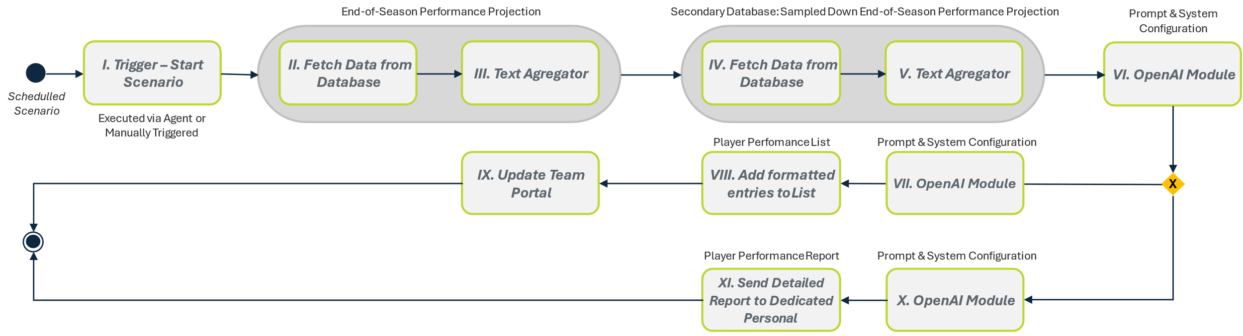
Figure 4.6 – “Workflow 3 – Performance Assessment” Key Modules

Team Management Platform
To ensure a centralized and explainable interface for coaches and managers, the framework includes a dedicated web-based team management platform. This system ingests all previously described workflow outputs automatically and presents the resulting insights in an accessible and interpretable manner, providing users with the necessary information to support more organized, connected, and effective team management.
This platform significantly enhances decision quality, reduces fragmentation and streamlines daily management tasks by giving coaches and managers immediate access to structured and interpretable insights.
For a detailed overview of the platform’s pages and available insights, please refer to Appendix B, which outlines the design structure and interface components employed throughout the framework’s development.

Athlete Passport
The Athlete Passport concept builds on the idea of integrating a holistic management system with a technology such as blockchain to be used in the sporting environment. Leveraging the capabilities explored in the literature review, blockchain can be used to create a tamper-proof digital record that consolidates all player information such as performance data, statistics, medical records, and historical milestones, within a single and verifiable structure. Each season would represent a new “block” added to the player’s ongoing “chain” enabling longitudinal analysis of averages, trends, and totals over time. This approach ensures data integrity, transparency, and secure team ownership, as highlighted by Bucea-Manea-Țoniș et al. (2025) in their study, where only the representing organization is authorized to manage and update the player’s digital profile.

Building on that foundation, a proof-of-concept (PoC) version of the “Athlete Passport” was developed and integrated into the team portal to visually demonstrate its potential capabilities and benefits (Annex B – “Figure B. 5 - Athlete Passport Page”). In addition to providing an overview of team performance through the previously developed features, this module allows managers and staff to access comprehensive player profiles with ease. It offers a complete view of each athlete’s background combining performance data, health records, and historical insights, thereby improving accuracy and enabling more in-depth analysis and informed decision-making.

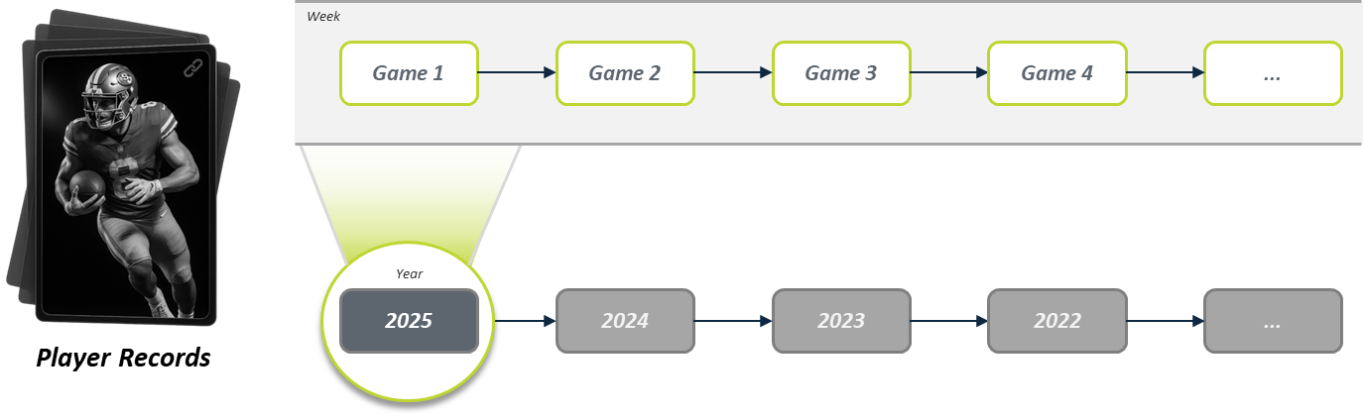
Figure 4.7 – “Athlete Passport” – Blockchain Approach
Additionally, if resources allow, the system could incorporate visual assets such as game-photos, key passes, catches, or goals, linking them into the player’s game log and minting them as non-fungible tokens (NFTs). These digital collectibles would be embedded in the player’s “Athlete Passport,” capturing historical career moments in a secure, blockchain-verified format. By offering this capability through the “Athlete Passport”, teams and players could unlock new revenue streams (via NFT sales or royalties) while deepening fan engagement. Moreover, the blockchain ledger ensures immutability, transparency, and traceable provenance of each collectible, which enhances trust in the asset’s authenticity and value.

In short, the integration of indexed visual highlights with blockchain-based NFTs within the Athlete Passport system not only supports career-long record keeping but also creates monetizable and fan-centric assets, turning player “memory-data” into lasting digital collectibles aligned with modern sports-technology trends.

Testing & Expected Outputs
The testing phase is aimed to evaluate the functionality and reliability of the developed workflows within the framework defined in the beginning of the chapter. Following the completion of the workflow solution design, intended to serve as the foundation for the AI Agent functionalities, tests were conducted to identify potential weaknesses and validate operational consistency. This stage also sought to confirm that the generated results adhered to an accessible, professional language suitable for managerial, medical, and dedicated personnel.
During the testing phase, validations were performed using the datasets previously described in the chapter. The original datasets contained over 3,000 entries, from which smaller samples were created to simulate realistic team conditions and to reflect the same resources teams would have to spend to execute these workflows. Specifically, the sampled-down datasets included up to 100 entries covering 21 weeks of seasonal data for defensive backs, typically representing no more than 10 players per team, and another dataset with 20 entries summarizing seasonal averages and totals for approximately 20 offensive playmakers, a relatively large group for that positional unit.
The initial full datasets remained integrated into the process and in the workflows for historical reference and analytical comparisons, sustaining insights produced by the OpenAI modules. In contrast, the sampled-down datasets were used to simulate real operational scenarios, providing a controlled environment that mirrors the scale and variability encountered in professional sports contexts. This methodological choice allowed the testing phase to assess both feasibility and resource cost-efficiency, reflecting the type of data volumes and conditions expected in live team applications.
Delving deeper into the testing of key module configurations, each test assessed whether the AI modules could accurately interpret the structured inputs, generate outputs in accordance with the predefined formats, and subsequently ensure that the routers correctly directed the resulting data through the designated workflow branches without errors. In this regard, prompt configuration emerged as a major determinant of output quality. The AI’s responses were constrained through predefined prompt templates containing strict structural rules to minimize hallucinations or unrealistic recommendations. This ensured that the generated insights remained aligned with real-world considerations; for instance, avoiding scenarios where high-performing athletes would be incorrectly flagged for transfer or rest without sufficient justification. To ensure validity, all generated outputs were reviewed for plausibility and alignment with realistic sporting contexts and evaluated for coherence based on domain-specific knowledge of the sport.
Additionally, considerable focus was placed on verifying that the automation performed consistently across repeated runs, a critical requirement for both reproducibility and operational reliability. Beyond technical validation, particular emphasis was placed on interpretability and practical usefulness. Each workflow was assessed by its ability to provide clear, context-aware insights that complement human expertise. The outputs were evaluated for linguistic clarity, logical consistency, resemblance to actual real-life possible outcomes, and for the degree to which they could directly support decision-making processes across managerial and medical contexts.
Expected Results
- Scenario 1 – Weekly Report
From a managerial standpoint, this workflow is expected to generate concise weekly reports summarizing both team and individual performances. Outputs should highlight overperforming, underperforming and fatigued players, presenting actionable recommendations for rest or workload management logically supported by the underlying data. Reports were required to maintain a consistent, professional structure and be interpretable without manual editing.
Technically, the workflow was expected to apply the defined Fatigue Index threshold (e.g., ≥ 0.79) consistently and reproduce nearly identical outputs when rerun on the same dataset. Stable execution times and automatic triggering of the linked “Injury Alerts” workflow served as indicators of proper integration. Any variations in classification, formatting, or failed process triggers would suggest pipeline instability or misconfiguration on the AI modules or on data transformation and require review.
- Scenario 2 – Injury Alerts
For medical and performance staff, this workflow was designed to deliver early, actionable alerts identifying players at risk of injury or excessive fatigue. Each alert should include a short summary detailing the cause, severity, and recovery plan, if needed, supported by the defined indices (Fatigue Index). Clarity and direct usability were prioritized to facilitate immediate intervention planning.
From a technical perspective, the workflow needed to ensure accurate player classification and maintain uniform structure across all outputs. Its branching logic had to operate seamlessly, routing one branch to store alerts in the database and another to produce detailed medical reports. Low false-positive rates, consistent field formatting, and stable data routing were critical indicators of success.
- Scenario 3 – Performance Assessment & Projection
From the management viewpoint, this workflow aimed to generate season-level analytical reports capturing long-term performance trajectories. The expected output was a set of insights identifying player improvement, stability, or decline, aiding strategic decisions such as contract renewals or transfers. The tone was expected to remain analytical yet accessible, explicitly linking observations to quantitative data.
Technically, the workflow’s performance was measured by data ingestion reliability and consistency of classification. The AI was required to apply identical evaluation thresholds, maintain standardized report formatting, and ensure all results were correctly stored in the season-level repository.
Summary and Final Considerations
To conclude, across all workflows, system behavior was defined by reliable produced outputs, data integrity, and interpretability. From an operational perspective, a high-quality output was one that made sense to end users and supported decisions without requiring post-processing or clarification. From a technical perspective, success was demonstrated through stable formatting, consistent logic, efficient runtime, ease of scalability (adding, changing or removing modules), and accurate data flow. Together, these dimensions ensured that the framework could deliver operationally meaningful insights, enabling practical applications in performance management and injury prevention while maintaining scalability for future deployments.

Results and Discussion
This chapter presents and discusses the results obtained from the execution of the developed workflows, both individually and as an integrated system. It assesses their effectiveness in producing consistent, interpretable, and actionable insights, while evaluating how well the framework performed in practical terms and to what extent the expected results were achieved. As no previous work has directly addressed the development of an Agentic AI framework in sports, there are no established benchmarks for direct comparison. Accordingly, the results are presented objectively, progressing from general evaluations to specific observations, and addressing both technical and practical dimensions while identifying opportunities for refinement and future improvement.

Results & Implications
- Scenario 1 – Weekly Report
The first scenario focused on generating weekly reports to monitor player condition and identify signs of fatigue, overload, and overall player game-performance. The workflow demonstrated reliable behavior, accurately flagging players whose fatigue index exceeded the defined threshold and correctly categorizing them into corresponding risk levels. It also effectively identified top performers through comparative analysis of player statistics, providing a consistent overview of weekly performance dynamics. The recommendations generated by the model, such as the need for rest or temporary load reduction, were consistent with real-life practices commonly applied in professional sports contexts. The AI-generated reports were clear, coherent, and maintained a consistent structure across executions, while the automated trigger system performed as expected. Despite the overall robustness of the results, the framework’s accuracy still depended to some degree on the quality of the data provided, highlighting the importance of reliable input information for precise outcomes.
The workflow described in section 4.2.1 generated the following output:
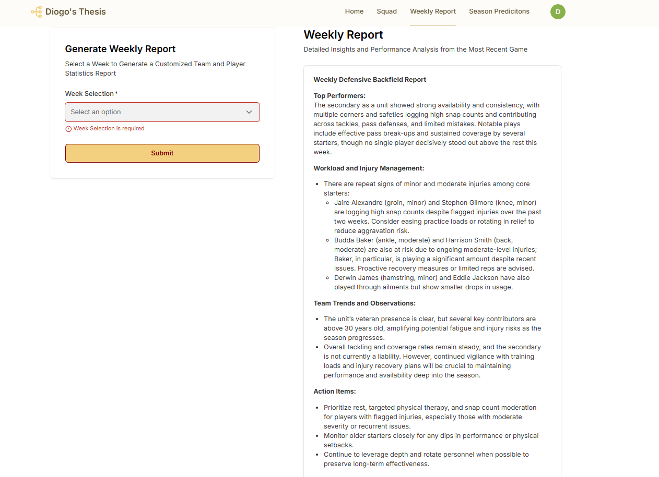
Figure 5.1 – “Workflow 1 – Weekly Report” Output
- Scenario 2 – Injury Alerts
The second scenario addressed injury alert generation. Here, the workflow demonstrated a solid capacity to flag potential injury risks, providing an associated severity range (high, medium and low) instead of a binary classification. This approach significantly reduced false positives and improved the model’s ability to capture both high-risk and low-risk cases that required monitoring. The framework was also capable of generating individualized recovery plans and incorporating contextual health data when available, which enhanced the relevance and utility of the outputs. The generated insights were easily interpretable, coherent, and meaningful for decision-making. However, the lack of labeled injury data restricted the development of a fully supervised model, requiring the system to depend primarily on fatigue and performance indices as comparative indicators for assessing player condition and potential risk. A richer, labeled dataset would likely improve calibration and enhance the predictive precision of the framework.
The workflow described in section 4.2.2 generated the following output:
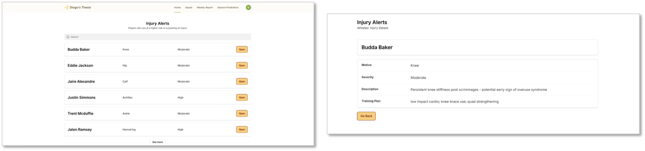
Figure 5.2 – “Workflow 2 – Injury Alerts” Output

- Scenario 3 – Performance Assessment & Projection
In the third scenario, which involved performance assessment and projection, the framework successfully identified player performance trends and estimated corresponding future status values (e.g., MVP candidate, reliable starter, developing player).
It differentiated clearly between improving, stagnant, and declining players while maintaining consistency in its evaluations. The integration of historical databases ensured continuity with previous seasons and allowed the analysis to reflect long-term development patterns. The framework’s data-driven design ensured that all assessments remained objective and free from emotional or preferential bias, as analyses were generated by AI and grounded entirely in quantifiable performance evidence.
The workflow described in section 4.2.3 generated the following output:
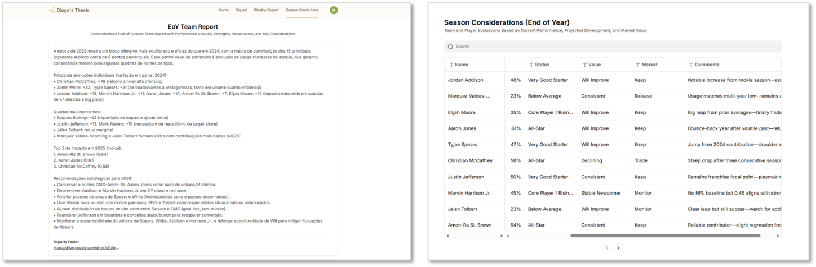
Figure 5.3 – “Workflow 3 – Performance Assessment” Output

Note: All figures are available in Appendix B, where they are presented with additional detail and further information about the platform.

When evaluated as an integrated system, the framework demonstrated coherence and scalability. The workflows operated seamlessly and capable of automatically triggering subsequent processes to ensure continuous data flow and system integration. This modular design allowed for straightforward expansion or modification, depending on the analytical goals. The short-term (weekly) and long-term (seasonal) analyses were also coherent, reinforcing the reliability of the framework’s outputs across different temporal contexts. The results were consistently interpretable and reproducible; however, the framework remains highly dependent on OpenAI features, making its performance and accessibility contingent on the stability, availability, and cost structure of that external service.

Additionally, as discussed in the response to SLRQ2, Agentic AI requires clean, real-time data and the authority to act rather than merely advise. However, current bottlenecks persist. Data fragmentation and the absence of standardized protocols remain major challenges, as sensor configurations, feature definitions, and evaluation methods differ significantly across contexts. These inconsistencies make the implementation of autonomous agents more challenging, a limitation also encountered in this study, with one of the reasons being due to the lack of fully tailored datasets. Nevertheless, with the establishment of a long-term data strategy at the club level, such data can be progressively collected, leading to more robust and effective outcomes.
From a practical standpoint, the qualitative indicators established at the beginning, like readability, interpretability, coherence, and usefulness for decision-making, were achieved. Reports were understandable to non-technical users, enabling effective communication between data analysts, coaches, and sports medicine staff. In terms of operational efficiency, each execution cycle, from data ingestion to final report generation, typically required less than two minutes. Additionally, when scheduled, the workflows executed smoothly and delivered results precisely when required, without any noticeable operational delays.

The framework supports multiple data-ingestion methods, enabling it to operate effectively in both high and low-resource environments. For professional teams equipped with wearable tracking devices such as active RFID tags and UWB sensors, data collection is largely automated. Active RFID tags transmit signals that track player positioning and movement in real time, while UWB sensors provide highly precise measurements of speed, acceleration, and spatial interactions within the playing field. Together, these technologies deliver live data that enhances the accuracy of fatigue and performance indicators, resulting in more precise, reliable, and contextually relevant analytical outputs, as stated by highlighted by Van Eetvelde et al. (2021). On the other hand, lower-level teams without such equipment can still use the system by manually recording training and game data. Although this approach introduces more human effort and less precision, the results remain valuable, providing accessible analytical support and load-management guidance at minimal cost. The flexibility of the framework thus ensures that it can be adopted by teams with varying resource levels, enabling and/ or improving access to data-driven performance analysis.

Costs & Constraints
Regarding implementation costs, these considerations further highlight the framework’s practical value and feasibility. According to estimates by the Economic Research Institute, the average salary for a sports analyst in the United States ranges from approximately $81,000 to $140,000 per year, and many professional teams employ multiple analysts, resulting in total personnel costs easily exceeding seven figures. The developed framework, by automating analytical processes and generating insights autonomously, can significantly reduce such costs or complement smaller analytics teams, enabling them to compete with more established departments.

The cost per single workflow execution (depending on the AI model version and data-processing module) remains only a fraction of traditional labor costs, averaging between $0.05 and $0.20 per execution while providing continuous availability and scalability. With the current configuration of two workflows running weekly and one annually, the operational expense amounts to approximately $0.10 - $0.40 per week, and, across a 21-week season plus the yearly execution, a total of $2.15 - $8.60 per year. This represents only a negligible fraction of the resources and manual effort typically invested in these activities, despite the substantial operational enhancements the system can deliver.

Summary of Findings
Nevertheless, certain limitations emerged during development and testing. Once again, the accuracy and depth of insights were constrained by the quality and completeness of available datasets, particularly the absence of confirmed injury labels and missing biometric parameters. Additionally, large language models remain sensitive to the phrasing of inputs and the context of data provided, which can affect reproducibility or cause minor deviations in results. Although safeguards were implemented to minimize hallucination and bias, human oversight is still advised for validations and to interpret critical outcomes. The reliance on third-party services, such as OpenAI, also introduces dependency considerations, as updates or pricing changes could affect reproducibility or cost predictability.

Despite these limitations, the framework demonstrates considerable potential for practical implementation. High-resource teams can leverage it for precise, real-time monitoring integrated with existing tracking systems, while lower-resource teams can adopt it as an affordable analytical assistant using manually entered data. In both cases, the system supports evidence-based decisions, optimizes workloads, and frees analysts to focus on higher-level interpretation rather than repetitive report generation. The results confirm that the framework can deliver meaningful, consistent, and actionable insights even under data constraints, encouraging broader adoption across different competitive levels.

Overall, the developed framework achieved its main objectives. It produced coherent and interpretable outputs, functioned efficiently as an integrated and scalable system, and demonstrated reliability across distinct use cases. The findings suggest that with improved data quality and additional labeled information, future iterations could further enhance prediction accuracy and impact. The framework thus provides a robust foundation for practical, data-driven decision-making in sports performance and injury management, with the capacity to evolve into an indispensable analytical tool for both elite and developing teams.

Conclusions and Future Research
This final chapter concludes the work developed in this dissertation by summarizing the main findings and identifying potential directions for future research and improvement. The results and discussion chapter confirm that the initial objectives and expected outcomes of the study were successfully achieved while also identifying certain limitations that may restrict the framework.
Considerations & Key Takeaways
To gain deeper insights and understand the current state of Agentic AI and its applications within the sports domain, the project began with an investigative literature review. By combining the knowledge derived from this review with practical expertise in the available tools and software capabilities used to develop the artifact, it was possible from the beginning
to conceptualize and design the proposed framework. As a result, the research objectives were successfully achieved, addressing the central research question: how to improve the quality, consistency, scalability, and availability of sports analytics data across different contexts using Agentic AI and AI-driven automations. This was accomplished through the design and implementation of a fully operational Agentic AI framework capable of delivering autonomous, data-driven insights for sports performance and injury management.
During the framework’s development, several limitations emerged, including the absence of labeled historical data required for training supervised models, inconsistencies in data quality, and constraints related to the use of available large language models used for output generation. Nevertheless, the system demonstrated promising results, particularly in terms of cost efficiency, scalability, and ease of integration, factors that strongly support its practical applicability. It is important to emphasize that the primary focus of this research lies in validating the framework itself and demonstrating the operational benefits of a scalable Agentic AI system, rather than optimizing the specific models used throughout development.
This perspective raises an important question: if the framework achieved these outcomes without access to purpose-built, high-quality data, how much greater could its performance become with dedicated datasets specifically designed to refine and enhance its underlying models?
Future Work
For future work, gaining access to higher-quality, labeled datasets through partnerships with top-tier clubs that already implement advanced monitoring and data collection processes could significantly enhance the framework’s capabilities. Integrating data from tracking technologies such as active RFID and UWB sensors, as described in the previous chapter, would enable more accurate validation and allow the framework to reach its full potential. Such collaborations would also support the development of new case studies, expanding the framework’s functionality and adaptability across different analytical contexts and capabilities.
Furthermore, conducting real-world applications of the framework across multiple sports and performance environments (ideally in partnership with professional clubs or sports institutions) would strengthen both its research and practical value. Testing it under varied conditions would allow for better evaluation of its scalability, robustness, and domain transferability but also limitations.
Another important avenue for future research concerns the ethical implications of deploying autonomous AI systems in sports analytics. While the framework can operate independently, maintaining human oversight is essential to ensure that AI-generated outputs remain coherent, fair, and contextually appropriate. Future studies could explore governance models that balance automation with accountability, establishing ethical standards for AI-driven decision support in sports management.
Finally, disseminating this research through academic journals, conferences, or scientific platforms would enhance its visibility and encourage collaboration between researchers, technologists, and practitioners. Broadening academic and public engagement could inspire further investigations and contribute to the continued advancement of AI applications in sports performance and health management.

Bibliographical References
Andersen, G. (2024, January 31). The role of data science in sports analytics and performance tracking. MoldStud - Custom Software Development Company. https://moldstud.com/articles/p-the-role-of-data-science-in-sports-analytics-and-performance-tracking
Bahr, R., Clarsen, B., Derman, W., Dvorak, J., Emery, C. A., Finch, C. F., Hägglund, M., Junge, A., Kemp, S., Khan, K. M., Marshall, S. W., Meeuwisse, W., Mountjoy, M., Orchard, J. W., Pluim, B., Quarrie, K. L., Reider, B., Schwellnus, M., Soligard, T., Chamari, K. (2020). International Olympic Committee consensus statement: methods for recording and reporting of epidemiological data on injury and illness in sport 2020 (including STROBE Extension for Sport Injury and Illness Surveillance (STROBE-SIIS)). British Journal of Sports Medicine, 54(7), 372–389. https://doi.org/10.1136/BJSPORTS-2019-101969
Bartels, F., Xing, L., Midoglu, C., Boeker, M., Kirsten, T., & Halvorsen, P. (2024). SoccerGuard: Investigating Injury Risk Factors for Professional Soccer Players with Machine Learning. arXiv (Cornell University). https://doi.org/10.48550/arxiv.2411.08901
Belzer, Jason (Fev 5, 2014). "Sports Industry 101: Breaking Into The Business Of Sports". Forbes.
Bitchell, C. L., Varley-Campbell, J., Robinson, G., Stiles, V., Mathema, P., & Moore, I. S. (2020). Recurrent and Subsequent Injuries in Professional and Elite Sport: a Systematic Review. Sports Medicine - Open, 6(1). https://doi.org/10.1186/s40798-020-00286-3
Bittencourt, N. F. N., Meeuwisse, W. H., Mendonça, L. D., Nettel-Aguirre, A., Ocarino, J. M., & Fonseca, S. T. (2016). Complex systems approach for sports injuries: moving from risk factor identification to injury pattern recognition-narrative review and new concept. British Journal of Sports Medicine, 50(21), 1309–1314. https://doi.org/10.1136/bjsports-2015-095850
Bucea-Manea-Țoniș, R., Antonescu, A. G., & Mihăilă, C. (2025). Blockchain in Sports: A Comparative analysis of applications and perceptions in football and basketball. Applied Sciences, 15(12), 6829. https://doi.org/10.3390/app15126829
Bunker, R., & Susnjak, T. (2022). The Application of machine learning techniques for predicting match results in Team Sport: a review. Journal of Artificial Intelligence Research, 73, 1285–1322. https://doi.org/10.1613/jair.1.13509
Claudino, J.G., Capanema, D.d., de Souza, T.V. et al. Current Approaches to the Use of Artificial Intelligence for Injury Risk Assessment and Performance Prediction in Team Sports: a Systematic Review. Sports Med - Open 5, 28 (2019). https://doi.org/10.1186/s40798-019-0202-3
Clemente, F. M., Afonso, J., Costa, J., Oliveira, R., Pino-Ortega, J., & Rico-González, M. (2021). Relationships between Sleep, Athletic and Match Performance, Training Load, and Injuries: A Systematic Review of Soccer Players. Healthcare 2021, Vol. 9, Page 808, 9(7), 808. https://doi.org/10.3390/HEALTHCARE9070808
Davis, J., Bransen, L., Devos, L., Jaspers, A., Meert, W., Robberechts, P., Van Haaren, J., & Van Roy, M. (2024). Methodology and evaluation in sports analytics: challenges, approaches, and lessons learned. Machine Learning, 113(9), 6977–7010. https://doi.org/10.1007/s10994-024-06585-0
Edouard, P., Dandrieux, P., Iatropoulos, S., Blanco, D., Branco, P., Chapon, J., Mulenga, D., Guex, K., Guilhem, G., Jacobsson, J., Mann, R., McCallion, C., Mosser, C., Morin, J., Prince, C., Ruffault, A., Timpka, T., Alonso, J., Tsukahara, Y., . . . Hollander, K. (2024). Injuries in Athletics (Track and Field): A narrative review presenting the current problem of injuries. Deutsche Zeitschrift Für Sportmedizin, 75(4), 132–141. https://doi.org/10.5960/dzsm.2024.601
Ekegren, C., Donaldson, A., Gabbe, B., Lloyd, D., Cook, J., & Finch, C. (2014). The facilitators and barriers to implementing injury surveillance systems alongside injury prevention programs. Journal of Science and Medicine in Sport, 18, e138–e139. https://doi.org/10.1016/j.jsams.2014.11.134
Ekegren, C.L., Gabbe, B.J. & Finch, C.F. Sports Injury Surveillance Systems: A Review of Methods and Data Quality. Sports Med 46, 49–65 (2016). https://doi.org/10.1007/s40279-015-0410-z
F. T. Liu, K. M. Ting and Z. -H. Zhou, "Isolation Forest," 2008 Eighth IEEE International Conference on Data Mining, Pisa, Italy, 2008, pp. 413-422, doi: 10.1109/ICDM.2008.17
Fagher, K., Dahlström, Ö., Jacobsson, J., Timpka, T., & Lexell, J. (2019). Prevalence of Sports‐Related injuries and illnesses in Paralympic athletes. PM&R, 12(3), 271–280. https://doi.org/10.1002/pmrj.12211
Fernandes, P., Nunes, S., & Santos, L. (2024, May). A Community-Driven Data-to-Text Platform for Football Match Summaries. In Proceedings of the 2024 Joint International Conference on Computational Linguistics, Language Resources and Evaluation (LREC-COLING 2024) (pp. 164-173)
George, G., Haas, M. R., & Pentland, A. (2014). Big data and management. Academy of Management Journal, 57(2), 321–326. https://doi.org/10.5465/amj.2014.4002
George, G., Osinga, E., Lavie, D., & Scott, B. (2016). Big data and data science methods for management research. Academy of Management Journal, 59(5), 1493–1507. https://doi.org/10.5465/amj.2016.4005
Haller, N., Blumkaitis, J. C., Strepp, T., Schmuttermair, A., Aglas, L., Simon, P., Neuberger, E., Kranzinger, C., Kranzinger, S., O’Brien, J., Ergoth, B., Raffetseder, S., Fail, C., Düring, M., & Stöggl, T. (2022). Comprehensive training load monitoring with biomarkers, performance testing, local positioning data, and questionnaires - first results from elite youth soccer. Frontiers in Physiology, 13. https://doi.org/10.3389/fphys.2022.1000898
Halson, S. L. (2014). Monitoring training load to understand fatigue in athletes. Sports Medicine, 44(S2), 139–147. https://doi.org/10.1007/s40279-014-0253-z
Hind, K., Konerth, N., Entwistle, I., Theadom, A., Lewis, G., King, D., Chazot, P., & Hume, P. (2020). Cumulative Sport-Related Injuries and Longer Term Impact in Retired Male Elite- and Amateur-Level Rugby Code Athletes and Non-contact Athletes: A Retrospective Study. Sports Medicine, 50(11), 2051–2061. https://doi.org/10.1007/s40279-020-01310-y
John, A. (2024). What are the Differences between Contact And Non Contact Sports? Unveiling the Distinctive Elements - The Sports Ground. Retrieved October 16, 2024, from https://thesportsground.com/what-are-the-differences-between-contact-and-non-contact-sports/
Kashyap, B., & Chowdhury, S. (2024). Blockchain Technology In Sports: Enhancing Athlete Mental And Cognitive Performance Tracking. Public Administration And Law Review, 4(20), 73–81. https://doi.org/10.36690/2674-5216-2024-4-73-81
Langton, J. (2024). Building a digital athlete: Using AI to rewrite the playbook on NFL player safety. https://www.nfl.com/playerhealthandsafety/equipment-and-innovation/aws-partnership/building-a-digital-athlete-using-ai-to-rewrite-the-playbook-on-nfl-player-safety
LeBoeuf Blanchette, Rebecca (Aug 18, 2022). "What is Sports Management?"
Leckey, C., Van Dyk, N., Doherty, C., Lawlor, A., & Delahunt, E. (2024). Machine learning approaches to injury risk prediction in sport:a scoping review with evidence synthesis. British Journal of Sports Medicine, bjsports-108576. https://doi.org/10.1136/bjsports-2024-108576
Liberati, A., Altman, D. G., Tetzlaff, J., Mulrow, C., Gøtzsche, P. C., Ioannidis, J. P. A., Clarke, M., Devereaux, P. J., Kleijnen, J., & Moher, D. (2009). The PRISMA statement for reporting systematic reviews and meta-analyses of studies that evaluate health care interventions: explanation and elaboration. In Journal of clinical epidemiology (Vol. 62, Issue 10). https://doi.org/10.1016/j.jclinepi.2009.06.00
Lin, Z. (2023). Ten simple rules for crafting effective prompts for large language models. SSRN Electronic Journal. https://doi.org/10.2139/ssrn.4565553
Lindsey, J. (2016). The NFL is finally tapping into the power of data. WIRED. https://www.wired.com/2016/01/the-nfls-impending-data-revolution
Mausehund, L., & Krosshaug, T. (2024). Knee biomechanics during cutting maneuvers and secondary ACL injury risk: A prospective cohort study of knee biomechanics in 756 female elite handball and soccer players. The American Journal of Sports Medicine, 52(5), 1209–1219. https://doi.org/10.1177/03635465241234255
Minnig, M. C., Hawkinson, L., Root, H. J., Driban, J., DiStefano, L. J., Callahan, L., Ambrose, K. R., Spang, J. T., & Golightly, Y. M. (2022). Barriers and facilitators to the adoption and implementation of evidence-based injury prevention training programmes: a narrative review. BMJ Open Sport & Exercise Medicine, 8(3), e001374. https://doi.org/10.1136/bmjsem-2022-001374
Moher, D. (2009). Preferred reporting items for systematic reviews and meta-analyses: the PRISMA statement. Journal of Clinical Epidemiology, 62(10), 1006–1012. https://doi.org/10.1016/j.jclinepi.2009.06.005
Munoz-Macho, A. A., Domínguez-Morales, M. J., & Sevillano-Ramos, J. L. (2024). Performance and healthcare analysis in elite sports teams using artificial intelligence: a scoping review. Frontiers in Sports and Active Living, 6. https://doi.org/10.3389/fspor.2024.1383723
Nassis, G., Verhagen, E., Brito, J., Figueiredo, P., & Krustrup, P. (2022). A review of machine learning applications in soccer with an emphasis on injury risk. Biology of Sport, 40(1), 233–239. https://doi.org/10.5114/biolsport.2023.114283
Owen, R., Owen, J. A., & Evans, S. L. (2024). Artificial Intelligence for Sport Injury Prediction. In Artificial Intelligence in Sports, Movement, and Health (pp. 69–79). https://doi.org/10.1007/978-3-031-67256-9_5
Pressler, A., & Niebauer, J. (2020). Textbook of Sports and Exercise Cardiology. In Springer eBooks. https://doi.org/10.1007/978-3-030-35374-2
Prieto-González, P., Martínez-Castillo, J. L., Fernández-Galván, L. M., Casado, A., Soporki, S., & Sánchez-Infante, J. (2021). Epidemiology of sports-related injuries and associated risk factors in adolescent athletes: An injury surveillance. International Journal of Environmental Research and Public Health, 18(9). https://doi.org/10.3390/ijerph18094857
Rossi, A., Pappalardo, L., Cintia, P., Iaia, F. M., Fernàndez, J., & Medina, D. (2018). Effective injury forecasting in soccer with GPS training data and machine learning. PLoS ONE, 13(7), e0201264. https://doi.org/10.1371/journal.pone.0201264
Shields, B. (2017). Integrating analytics in your organization: Lessons from the sports industry. MIT Sloan Management Review.
Sprouse, B., Chandran, A., Rao, N., Boltz, A. J., Johnson, M., Hennis, P., & Varley, I. (2024). Injury and illness surveillance monitoring in team sports: a framework for all. Injury Epidemiology, 11(1). https://doi.org/10.1186/s40621-024-00504-6
Topol, E. J. (2018). High-performance medicine: the convergence of human and artificial intelligence. Nature Medicine, 25(1), 44–56. https://doi.org/10.1038/s41591-018-0300-7
Van Eetvelde, H., Mendonça, L.D., Ley, C. et al. Machine learning methods in sport injury prediction and prevention: a systematic review. J EXP ORTOP 8, 27 (2021). https://doi.org/10.1186/s40634-021-00346-x
Vincent, H. K., Brownstein, M., & Vincent, K. R. (2022). Injury prevention, safe training techniques, rehabilitation, and return to sport in trail runners. Arthroscopy Sports Medicine and Rehabilitation, 4(1), e151–e162. https://doi.org/10.1016/j.asmr.2021.09.032
Wang, C., Stovitz, S. D., Kaufman, J. S., Steele, R. J., & Shrier, I. (2024). Principles of musculoskeletal sport injuries for epidemiologists: a review. Injury Epidemiology 2024 11:1, 11(1), 1–13. https://doi.org/10.1186/S40621-024-00507-3
Watanabe, N. M., Shapiro, S., & Drayer, J. (2021). Big data and analytics in sport management. Journal of Sport Management, 35(3), 197–202. https://doi.org/10.1123/jsm.2021-0067
Zadeh, A., Taylor, D., Bertsos, M., Tillman, T., Nosoudi, N., & Bruce, S. (2021). Predicting Sports Injuries with Wearable Technology and Data Analysis. Information Systems Frontiers, 23(4), 1023–1037. https://doi.org/10.1007/S10796-020-10018-3/TABLES/10

Appendix A – Datasets
This appendix details the datasets used in this thesis, including the parameters and features assessed within each one.
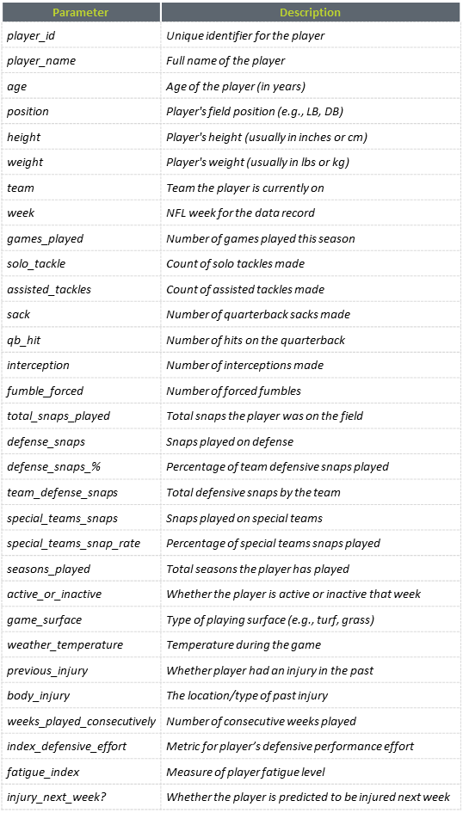
Table A. 1 - Weekly Report & Injury Risk Dataset

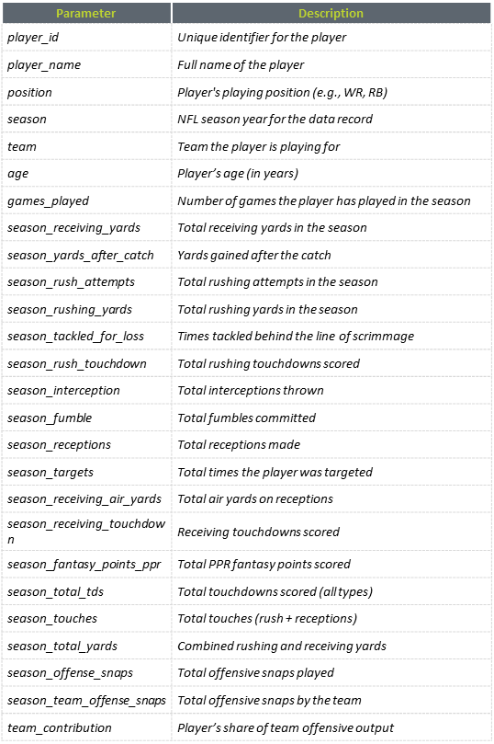
Table A. 2 - End-of-Season Performance Projection Dataset

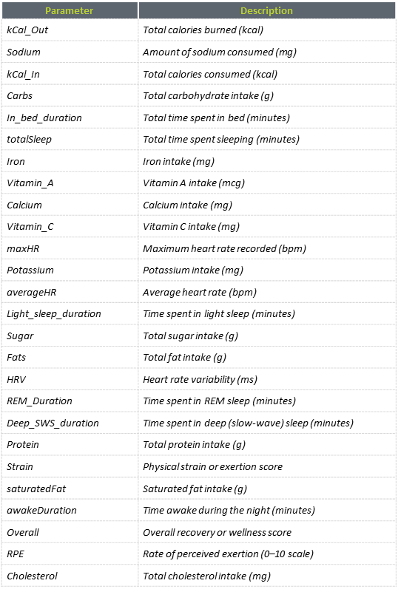
Table A. 3 - Benchmark Health & Performance Measures Dataset

Appendix B – Team Management Platform
This appendix describes each interface of the web-based team management platform, where outputs generated by the automated workflows are automatically ingested and displayed in their respective sections, along with the insights.

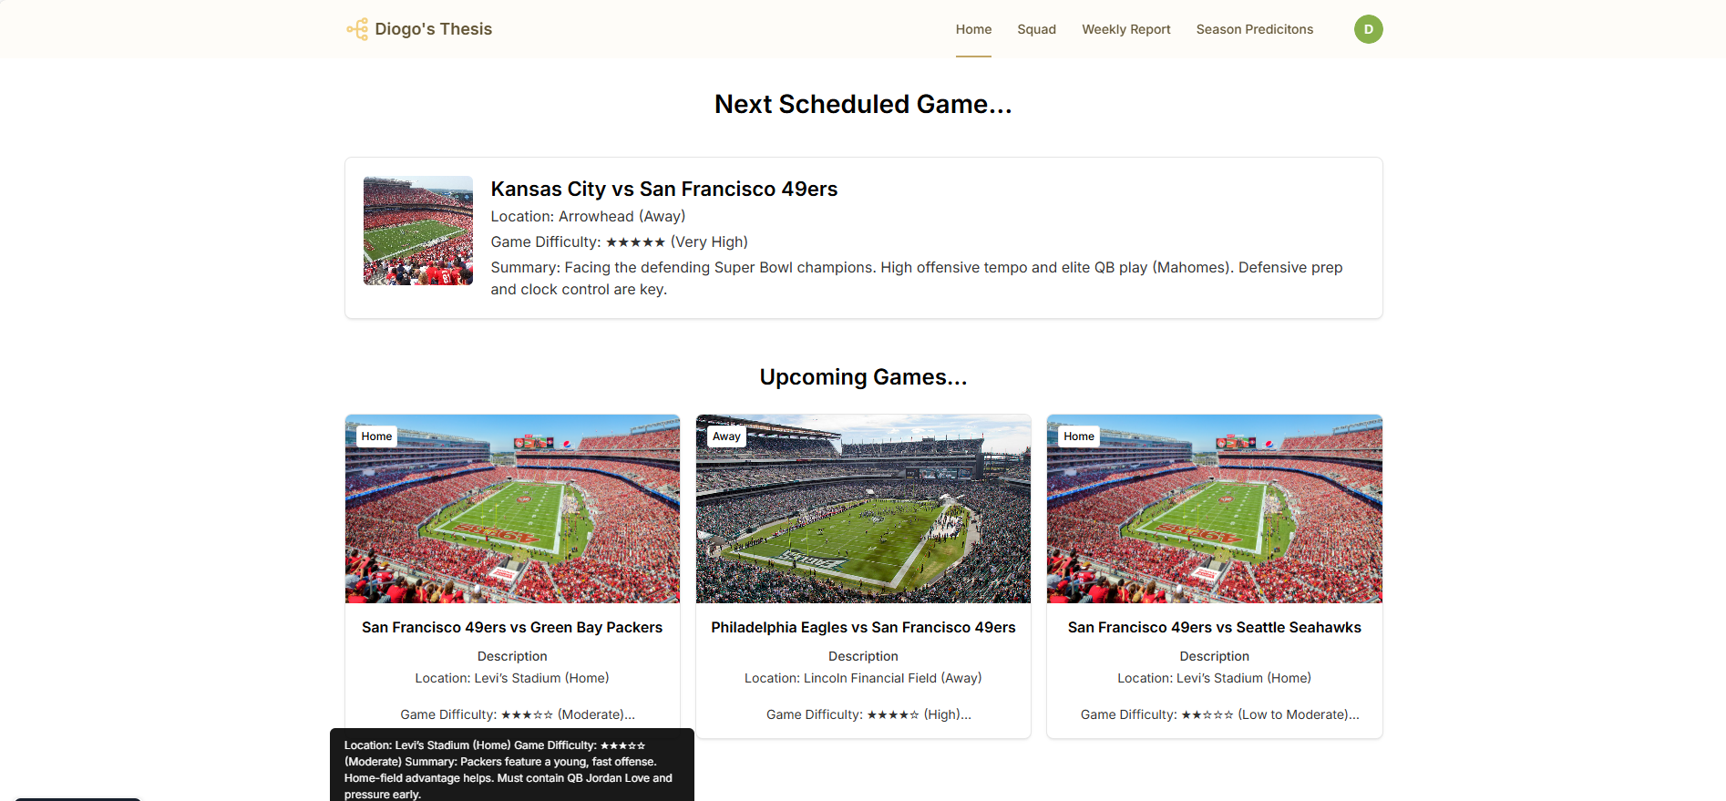
Figure B. 1 - Home Page

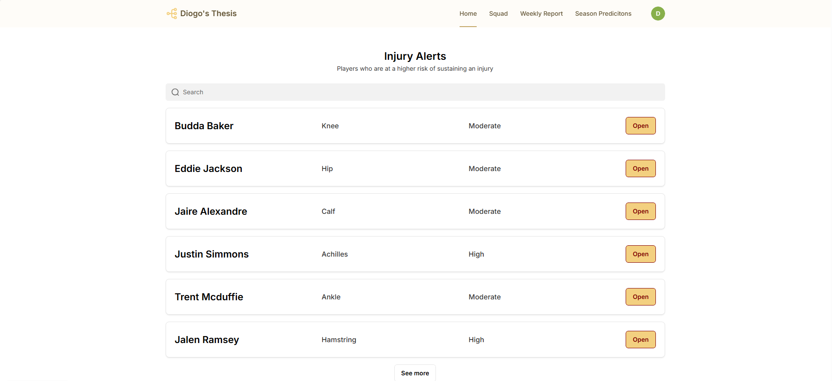
Figure B. 2 - Injury Alerts Page
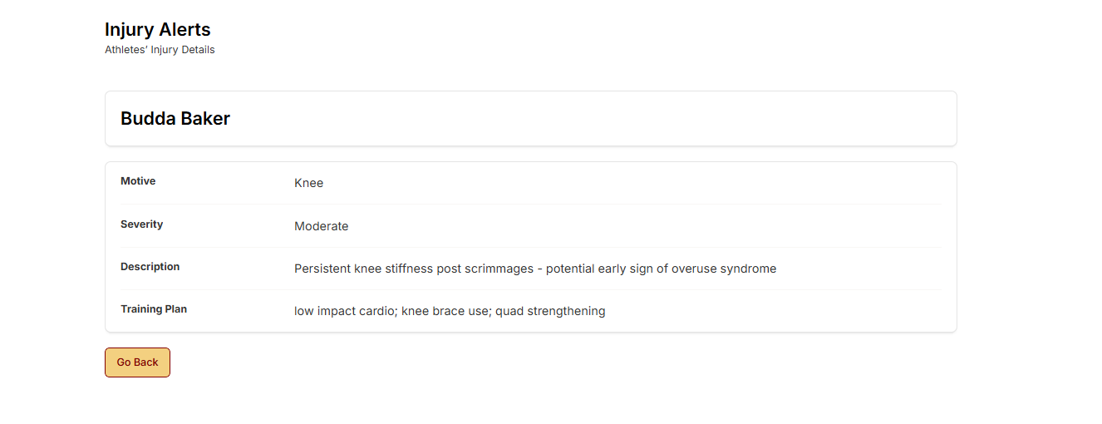
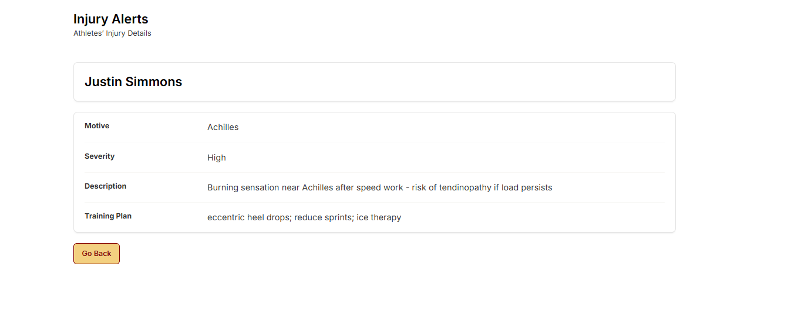
Figure B. 3 - Injury Alerts Detail Page

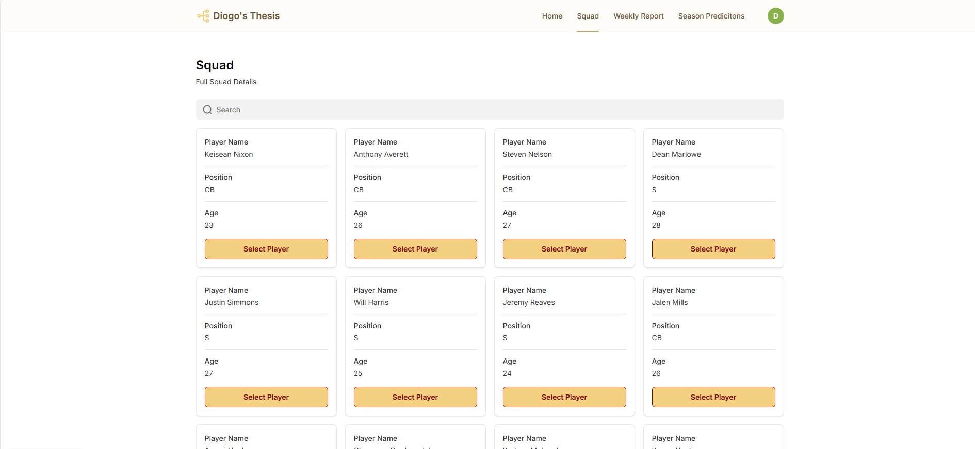
Figure B. 4 - Squad List Page

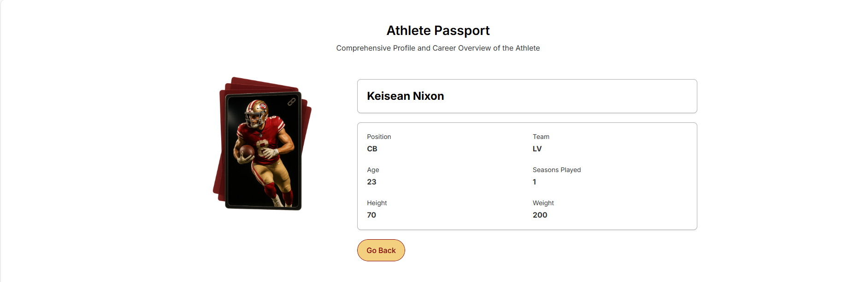
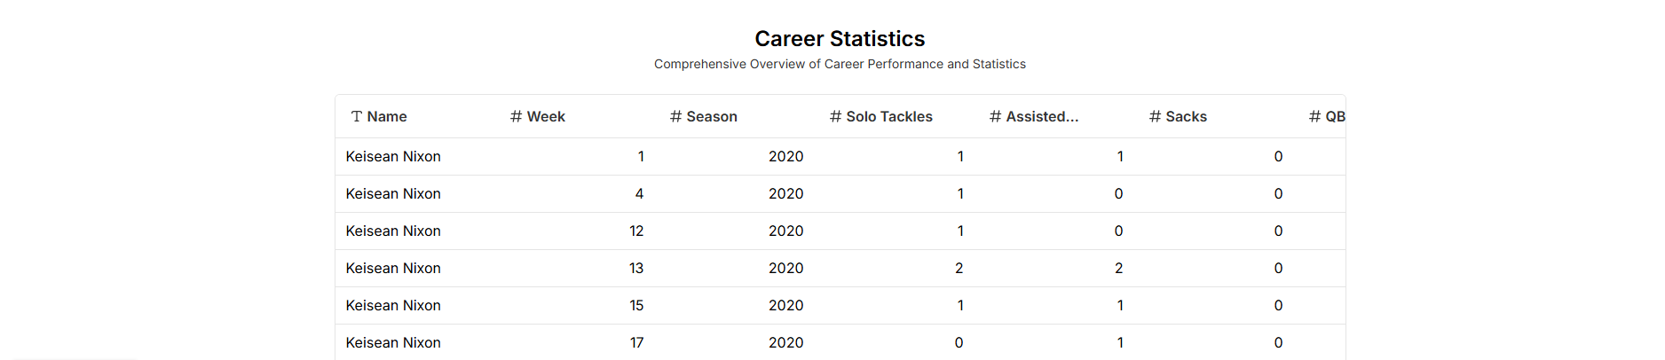
Figure B. 5 - Athlete Passport Page

Figure B. 6 - Weekly Report Page
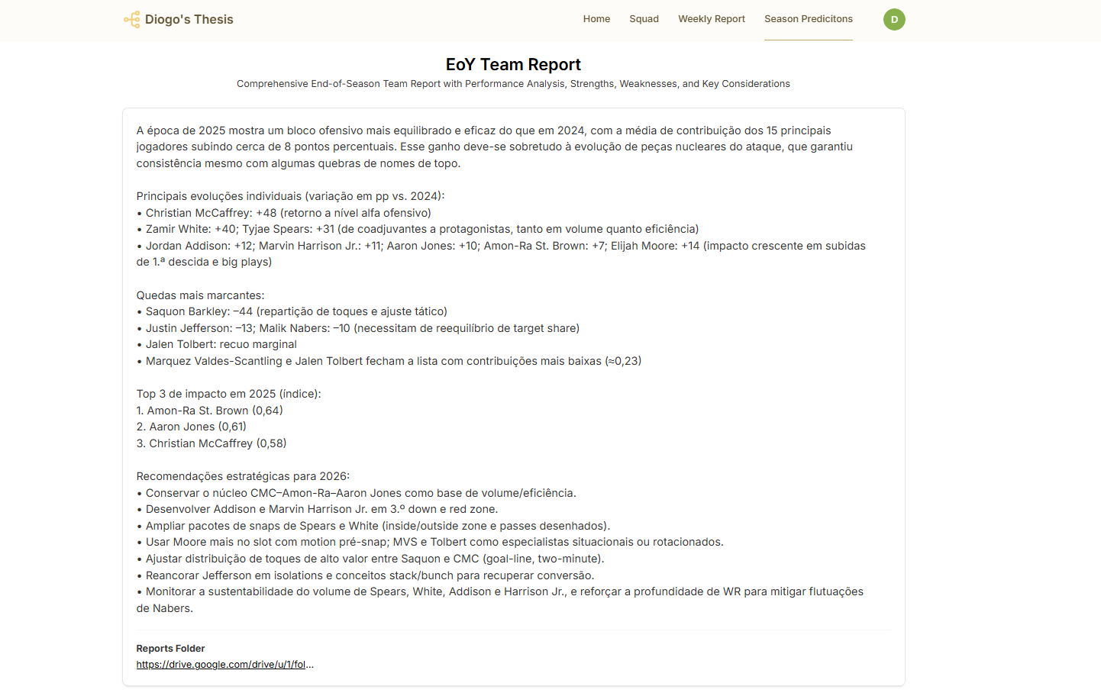
Figure B. 7 - End-of-Year Report Page

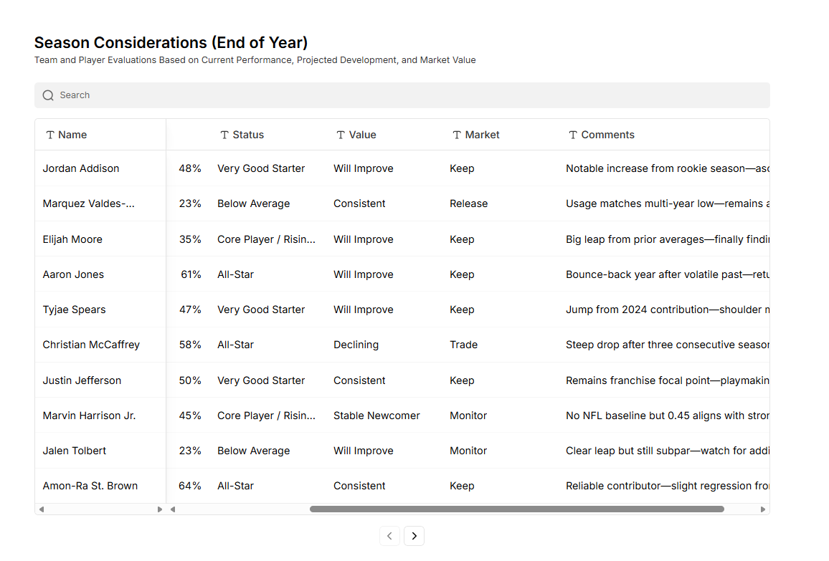
Figure B. 8 - End-of-Year Player Projections Page
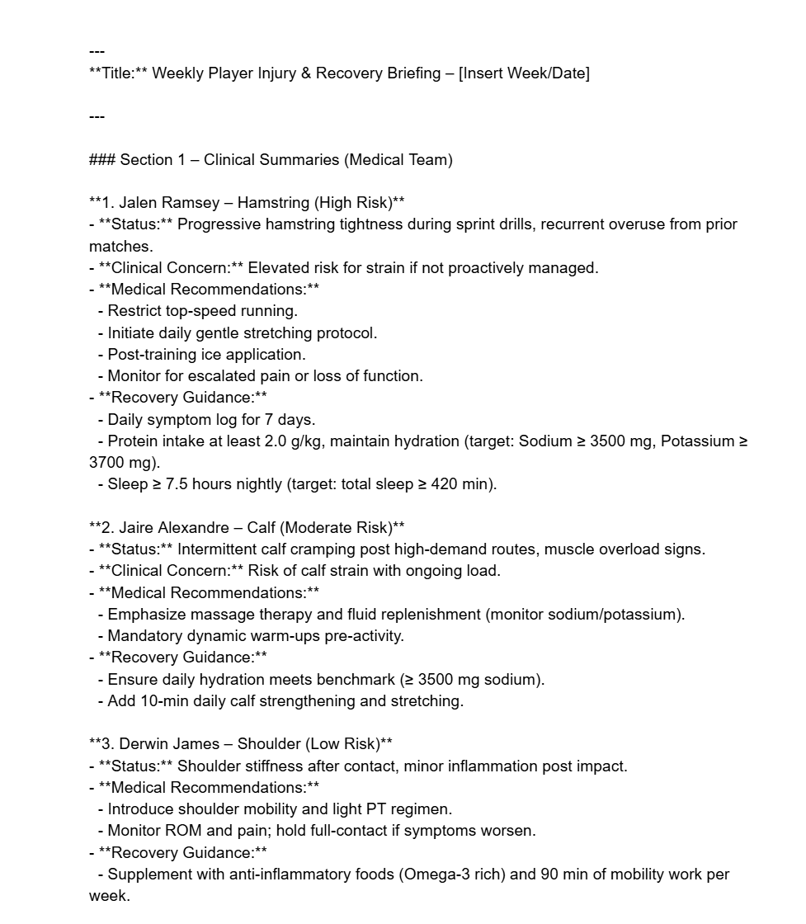
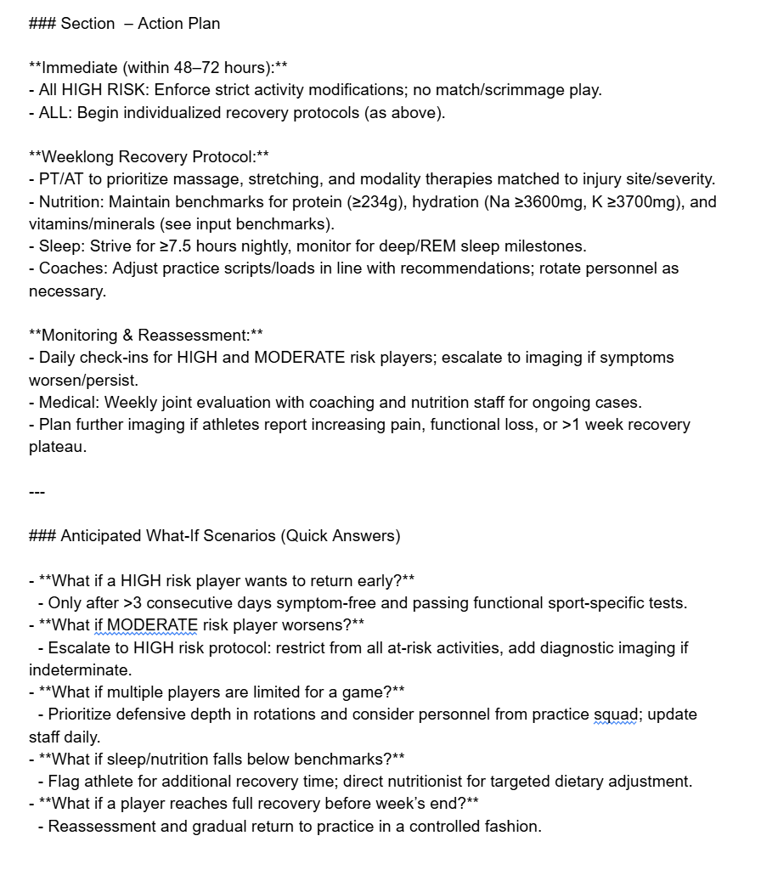
Figure B. 9 – [Example] Medical/ Recovery Plan Report

Appendix C
[Appendixes are for materials, tables, or more explanation material only done by the student]
[It is mandatory to include in the appendixes the Ethics Committee Report when the research “[… involves human participants and personal data, regardless of whether it is collected online or in person, whether it is based on a survey, an experiment, a dataset, or interviews (i.e., it is also compulsory for observational studies and field interviews with managers)]”. You must get your report by answering a short questionnaire available here: https://novaims.eu.qualtrics.com/jfe/form/SV_eG085IyOwAj6a57



